 |  | UM1724 User manual
STM32 Nucleo-64 boards (MB1136)
Introduction
The STM32 Nucleo-64 boards based on the MB1136 reference board (NUCLEO-F030R8, NUCLEO-F070RB, NUCLEO-F072RB, NUCLEO-F091RC, NUCLEO-F103RB,
NUCLEO-F302R8, NUCLEO-F303RE, NUCLEO-F334R8, NUCLEO-F401RE,
NUCLEO-F410RB, NUCLEO-F411RE, NUCLEO-F446RE, NUCLEO-L010RB,
NUCLEO-L053R8, NUCLEO-L073RZ, NUCLEO-L152RE, NUCLEO-L452RE,
NUCLEO-L476RG) provide an affordable and flexible way for users to try out new concepts and build prototypes with the STM32 microcontrollers in the LQFP64 package, choosing
from the various combinations of performance, power consumption, and features. The
ARDUINO® Uno V3 connectivity support and the ST morpho headers provide an easy
means of expanding the functionality of the Nucleo open development platform with a wide choice of specialized shields. The STM32 Nucleo boards do not require any separate probe as they integrate the ST-LINK/V2-1 debugger and programmer. The STM32 Nucleo boards come with the comprehensive free software libraries and examples available with the
STM32Cube MCU Packages.

Figure 1. STM32 Nucleo-64 board

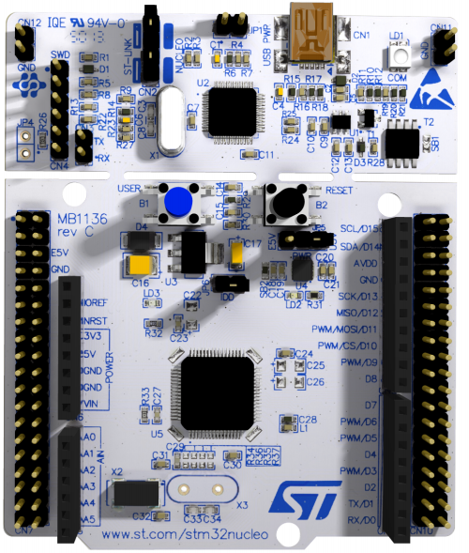
Picture is not contractual.

September 2025 UM1724 Rev 17 1/91
www.st.com

Contents

1 Features 6

2 Ordering information 7
2.1 Codification 8

3 Development environment 9
3.1 System requirements 9
3.2 Development toolchains 9
3.3 Demonstration software 9
3.4 EDA resources 9

4 Conventions 10

5 Safety recommendations 11
5.1 Targeted audience 11
5.2 Handling the board 11

6 Quick start 12
6.1 Getting started 12
6.2 Hardware configuration variants 12

7 Hardware layout and configurat ion 13
7.1 Board diagram and layout 13
7.2 Mechanical dimensions 16
7.3 Pre-cut PCB 17
7.4 Embedded ST-LINK/V2-1 17
7.4.1 Driver 18
7.4.2 ST-LINK/V2-1 firmware upgrade 18
7.4.3 Mass storage interface 18
7.4.4 Using the ST-LINK/V2-1 to program and debug the STM32 on board . 18
7.4.5 Using ST-LINK/V2-1 to program and debug an external
STM32 application 19
7.5 Power supply and power selection 21
7.5.1 Power supply input from the USB connector 21

2/91 UM1724 Rev 17

7.5.2 External power supply inputs: VIN and E5V 22
7.5.3 External power supply input: +3.3V 23
7.5.4 External power supply output 23
7.6 LEDs 24
7.7 Push-buttons 24
7.8 JP6 (IDD) 24
7.9 OSC clock 25
7.9.1 OSC clock supply 25
7.9.2 OSC 32 KHz clock supply 26
7.10 USART communication 26
7.11 Solder bridges 27
7.12 Extension connectors 29
7.13 ARDUINO® connectors 38
7.14 ST morpho connector 54

8 Nucleo-64 boards information 64
8.1 Product marking 64
8.2 Product history 65
8.3 Board revision history 83
9 Federal Communications Commission (FCC) and ISED Canada
Compliance Statements 85
9.1 FCC Compliance Statement 85
9.2 ISED Compliance Statement 86

10 Product disposal 87
Revision history 88


UM1724 Rev 17 3/91

List of tables

Table 1. Ordering information 7
Table 2. Codification explanation 8
Table 3. ON/OFF conventions 10
Table 4. Jumper states 17
Table 5. Debug connector CN4 (SWD) 20
Table 6. JP1 configuration table 21
Table 7. External power sources 22
Table 8. Power-related jumper 22
Table 9. +3.3 V external power source 23
Table 10. Solder bridges 27
Table 11. ARDUINO® connectors on NUCLEO-F030R8, NUCLEO-F070RB,
NUCLEO-F072RB, NUCLEO-F091RC 38
Table 12. ARDUINO® connectors on NUCLEO-F103RB 40
Table 13. ARDUINO® connectors on NUCLEO-F302R8 41
Table 14. ARDUINO® connectors on NUCLEO-F303RE 42
Table 15. ARDUINO® connectors on NUCLEO-F334R8 43
Table 16. ARDUINO® connectors on NUCLEO-F401RE and NUCLEO-F411RE 44
Table 17. ARDUINO® connectors on NUCLEO-L053R8 46
Table 18. ARDUINO® connectors on NUCLEO-L010RB and NUCLEO-L073RZ 47
Table 19. ARDUINO® connectors on NUCLEO-F446RE 48
Table 20. ARDUINO® connectors on NUCLEO-F410RB 50
Table 21. ARDUINO® connectors on NUCLEO-L152RE 51
Table 22. ARDUINO® connectors on NUCLEO-L452RE 52
Table 23. ARDUINO® connectors on NUCLEO-L476RG 53
Table 24. ST morpho connector on NUCLEO-F030R8 54
Table 25. ST morpho connector on NUCLEO-F070RB 55
Table 26. ST morpho connector on
NUCLEO-F072RB, NUCLEO-F091RC, NUCLEO-F303RE, NUCLEO-F334R8 56
Table 27. ST morpho connector on NUCLEO-F103RB 57
Table 28. ST morpho connector on NUCLEO-F302R8 58

Table 29. ST morpho connector on NUCLEO-F401RE,
NUCLEO-F411RE, NUCLEO-F446RE 59
Table 30. ST morpho connector on NUCLEO-L010RB,
NUCLEO-L053R8, NUCLEO-L073RZ, NUCLEO-L152RE 60
Table 31. ST morpho connector on NUCLEO-L452RE 61
Table 32. ST morpho connector on NUCLEO-L476RG 62
Table 33. ST morpho connector on NUCLEO-F410RB 63
Table 34. Product history 65
Table 35. Board revision history 83
Table 36. Document revision history 88

4/91 UM1724 Rev 17

List of figures

Figure 1. STM32 Nucleo-64 board 1
Figure 2. Hardware block diagram 13
Figure 3. Top layout 14
Figure 4. Bottom layout 15
Figure 5. STM32 Nucleo board mechanical dimensions 16
Figure 6. Updating the list of drivers in the Device Manager 18
Figure 7. Connecting the STM32 Nucleo board to program the on-board STM32 19
Figure 8. Using ST-LINK/V2-1 to program the STM32 on an external application 20
Figure 9. NUCLEO-F030R8 29
Figure 10. NUCLEO-F070RB 29
Figure 11. NUCLEO-F072RB 30
Figure 12. NUCLEO-F091RC 30
Figure 13. NUCLEO-F103RB 31
Figure 14. NUCLEO-F302R8 31
Figure 15. NUCLEO-F303RE 32
Figure 16. NUCLEO-F334R8 32
Figure 17. NUCLEO-F401RE 33
Figure 18. NUCLEO-F411RE 33
Figure 19. NUCLEO-L053R8 34
Figure 20. NUCLEO-L073RZ and NUCLEO-L010RB 34
Figure 21. NUCLEO-L152RE 35
Figure 22. NUCLEO-L452RE 35
Figure 23. NUCLEO-L476RG 36
Figure 24. NUCLEO-F446RE 36
Figure 25. NUCLEO-F410RB 37

UM1724 Rev 17 5/91

1 Features

The STM32 Nucleo board offers the following features:
• Arm® Cortex®(a) core-based STM32 microcontroller in LQFP64 package
• Three LEDs:
– USB communication (LD1), user LED (LD2), power LED (LD3)
• Two push-buttons: USER and RESET
• Two types of extension resources
– ARDUINO® Uno V3 connectivity
– ST morpho extension pin headers for full access to all STM32 I/Os
• Flexible board power supply:
– USB VBUS or external source (3.3 V, 5 V, 7-12 V)
– Power management access point
• On-board ST-LINK/V2-1 debugger and programmer with SWD connector
– Selection-mode switch using the kit as a standalone ST-LINK/V2-1
• USB re-enumeration capability. Three different interfaces are supported on USB:
– Virtual COM port
– Mass storage
– Debug port
• Comprehensive free software libraries and examples available with the STM32Cube MCU Package

a. Arm and Cortex are registered trademarks of Arm Limited (or its subsidiaries) in the US and/or elsewhere.

6/91

UM1724 Rev 17

2 Ordering information

To order an STM32 Nucleo-64 board, refer to Table 1. Additional information is available from the datasheet and reference manual of the target STM32.

Table 1. Ordering information

Order code | Board reference | Targeted STM32
NUCLEO-F030R8 | MB1136 | STM32F030R8T6
NUCLEO-F070RB | MB1136 | STM32F070RBT6
NUCLEO-F072RB | MB1136 | STM32F072RBT6
NUCLEO-F091RC | MB1136 | STM32F091RCT6
NUCLEO-F103RB | MB1136 | STM32F103RBT6
NUCLEO-F302R8 | MB1136 | STM32F302R8T6
NUCLEO-F303RE | MB1136 | STM32F303RET6
NUCLEO-F334R8 | MB1136 | STM32F334R8T6
NUCLEO-F401RE | MB1136 | STM32F401RET6
NUCLEO-F410RB | MB1136 | STM32F410RBT6
NUCLEO-F411RE | MB1136 | STM32F411RET6
NUCLEO-F446RE | MB1136 | STM32F446RET6
NUCLEO-L010RB | MB1136 | STM32L010RBT6
NUCLEO-L053R8 | MB1136 | STM32L053R8T6
NUCLEO-L073RZ | MB1136 | STM32L073RZT6
NUCLEO-L152RE | MB1136 | STM32L152RET6
NUCLEO-L452RE | MB1136 | STM32L452RET6
NUCLEO-L476RG | MB1136 | STM32L476RGT6

UM1724 Rev 17 7/91

2.1 Codification
The meaning of the codification is explained in Table 2.

Table 2. Codification explanation

NUCLEO-XXYYRT | Description | Example: NUCLEO-L452RE
XX | MCU series in STM32 Arm Cortex MCUs | STM32L4 Series
YY | STM32 product line in the series | STM32L452
R | STM32 package pin count | 64 pins
T | STM32 flash memory size:  – 8 for 64 Kbytes  – B for 128 Kbytes  – C for 256 Kbytes  – E for 512 Kbytes  – G for 1 Mbyte  – Z for 192 Kbytes | 512 Kbytes

8/91 UM1724 Rev 17

3 Development environment

3.1 System requirements
• Multi-OS support: Windows® 10 or 11, Linux® 64-bit, or macOS®
• USB Type-A or USB Type-C® to Micro-B cable, or USB Type-A or USB Type-C® to Mini-B cable, or USB Type-A or USB Type-C® to USB Type-C® cable (depending on the board reference)
Note: macOS® is a trademark of Apple Inc., registered in the U.S. and other countries and regions.
Linux® is a registered trademark of Linus Torvalds.
Windows® is a trademark of the Microsoft group of companies

3.2 Development toolchains
• IAR Systems - IAR Embedded Workbench®(a)
• Keil®: MDK-ARM(a)
• STMicroelectronics - STM32CubeIDE

3.3 Demonstration software
The demonstration software, included in the STM32Cube MCU Package corresponding to the on-board microcontroller, is preloaded in the STM32 flash memory for easy
demonstration of the device peripherals in standalone mode. The latest versions of the demonstration source code and associated documentation can be downloaded from www.st.com.

3.4 EDA resources
All board design resources, including schematics, EDA databases, manufacturing files, and the bill of materials are available from the corresponding product page at www.st.com.

a. On Windows® only.
UM1724 Rev 17 9/91

4 Conventions

Table 3 provides the conventions used for the ON and OFF settings in the present document.

Table 3. ON/OFF conventions

Convention | Definition
Jumper JP1 ON | Jumper fitted
Jumper JP1 OFF | Jumper not fitted
Solder bridge SBx ON | SBx connections closed by solder or 0-ohm resistor
Solder bridge SBx OFF | SBx connections left open
In this document, the references are “STM32 Nucleo board” and “STM32 Nucleo boards” for all information that is common to all sale types.

10/91 UM1724 Rev 17

5 Safety recommendations

5.1 Targeted audience
This product targets users with at least basic electronics or embedded software
development knowledge such as engineers, technicians, or students. This board is not a toy and is not suited for use by children.

5.2 Handling the board
This product contains a bare printed circuit board and like all products of this type, the user must be careful about the following points:
• The connection pins on the board might be sharp. Be careful when handling the board to avoid hurting yourself.
• This board contains static-sensitive devices. To avoid damaging it, handle the board in an ESD.proof environment.
• While powered, do not touch the electric connections on the board with your fingers or anything conductive. The board operates at a voltage level that is not dangerous, but components might be damaged when shorted.
• Do not put any liquid on the board and avoid operating the board close to water or at a high humidity level.
• Do not operate the board if it is dirty or dusty.

UM1724 Rev 17 11/91

6 Quick start

The STM32 Nucleo board is a low-cost and easy-to-use development platform used to quickly evaluate and start development with an STM32 microcontroller in an LQFP64 package.
Before installing and using the product, accept the Evaluation Product License Agreement from the www.st.com/epla web page.
For more information on the STM32 Nucleo board and to access the demonstration software, visit www.st.com/stm32nucleo website.

6.1 Getting started
Follow the sequence below to configure the STM32 Nucleo board and launch the demo software:
1. Check the jumper position on the board, JP1 off, JP5 (PWR) on U5V, JP6 on (IDD), CN2 on (NUCLEO) selected.
2. For correct identification of all device interfaces from the host PC, install the Nucleo USB driver available from the www.st.com/stm32nucleo web page, before connecting the board.
3. Connect the STM32 Nucleo board to a PC with a USB cable ‘Type-A to Mini-B’ through USB connector CN1 to power the board. The red LED LD3 (PWR) and LD1 (COM)
must light up. LD1 (COM) and green LED LD2 must blink.
4. Press button B1 (left button).
5. Observe the blinking frequency of LED LD2 at different frequencies, by clicking on the button B1.
6. The demonstration software and several software examples on how to use the STM32 Nucleo board features are available at the www.st.com/stm32nucleo web page.
7. Develop the application using the available examples.

6.2 Hardware configuration variants
The board can be delivered with different configurations of the oscillator of the target
STM32. For all the details concerning high-speed configurations of the oscillator refer to Section 7.9.1. For all the details concerning low-speed configurations of the oscillator refer to Section 7.9.2.

12/91 UM1724 Rev 17 

7 Hardware layout and configuration

The STM32 Nucleo board is designed around the STM32 microcontrollers in a 64-pin LQFP package.
Figure 2 shows the connections between the STM32 and its peripherals (ST-LINK/V2-1, push-button, LED, ARDUINO® connectors, and ST morpho connector).
Figure 3 and Figure 4 show the location of these features on the STM32 Nucleo board.
Figure 5 shows the mechanical dimensions of the STM32 Nucleo board.

7.1 Board diagram and layout

Figure 2. Hardware block diagram
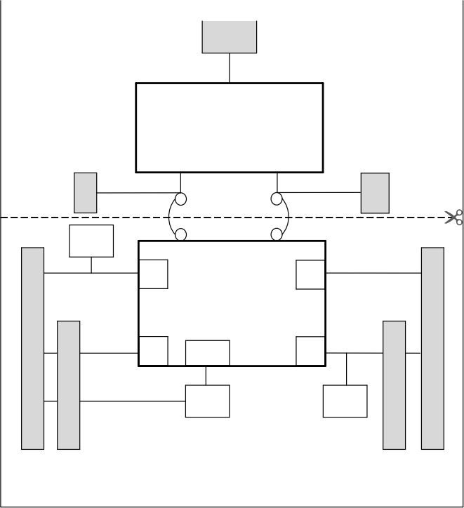  SWD  VCP  UART  ST morpho extension header  ARD U I NO® connector  ARDUIonnec or  ST morpho extension header  ST-LINK part  Mini  STM32  Microcontroller  RESET  B2  RESET  IO  IO  LED  LD4  Embedded ST-LINK/V2-1  IO  IO  MCU part  B1  USER  USB | MS34374V3

UM1724 Rev 17 13/91

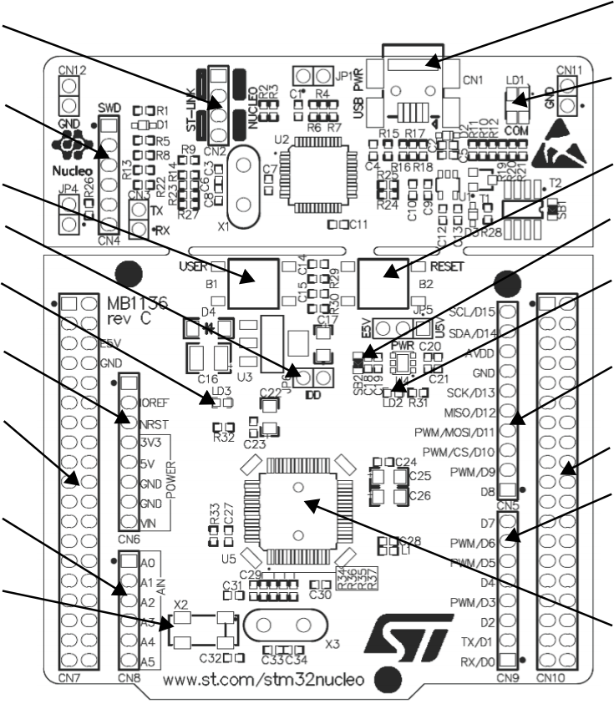Hardware layout and configuration UM1724
CN1
ST-LINK USB
mini B connector
LD1
(Red/Green LED) COM

B2
RESET button
SB2
3.3 V regulator output
LD2
(Green LED)

CN5
ARDUINO® connector

CN10
ST morpho connector CN9
ARDUINO® connector

U5
STM32
microcontroller
CN2
ST-LINK/Nucleo selector
CN4 SWD connector

B1 USER button
JP6 IDD measurement LD3 (Red LED) power
CN6 ARDUINO® connector
CN7 ST morpho connector
CN8 ARDUINO® connector
32 KHz crystal(1)

Figure 3. Top layout

MS34376V3
1. Crystal might be present or not depending on the board version. Refer to Section 7.9.2.

14/91 UM1724 Rev 17

Figure 4. Bottom layout
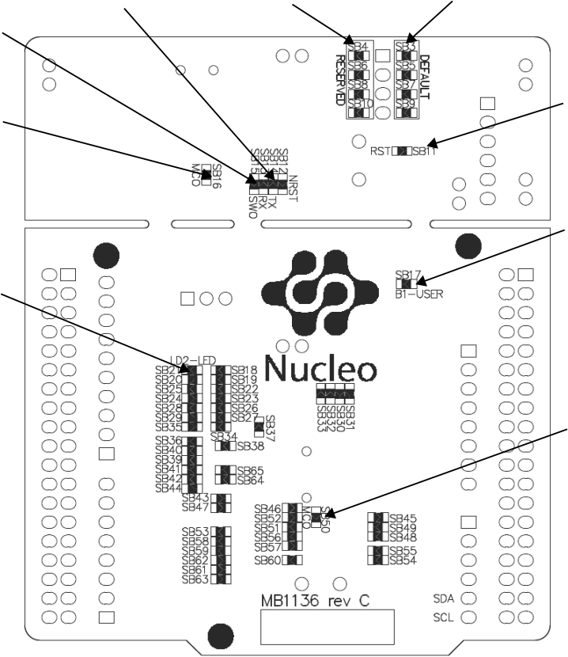

ST-LINK USART
SB13, SB14
SB3, SB5, SB7, SB9 (DEFAULT)
SB4, SB6, SB8, SB10 (RESERVED)
SB15
ST-LINK SWO
SB11
SB16
ST-LINK RESET
ST-LINK MCO

SB17
USER button
SB21 USER LED

SB50
ST-LINK MCO
MS34375V1

UM1724 Rev 17 15/91

7.2 Mechanical dimensions

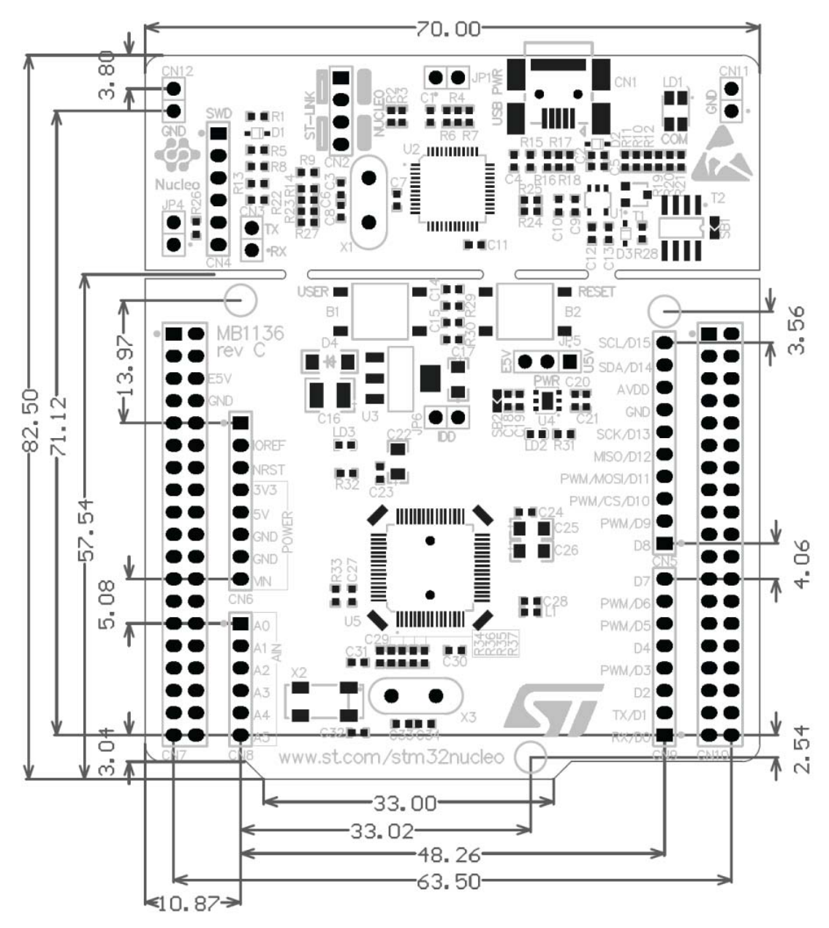
Figure 5. STM32 Nucleo board mechanical dimensions



16/91 UM1724 Rev 17

7.3 Pre-cut PCB
The STM32 Nucleo board is divided into two parts: the ST-LINK part and the target STM32 part. The ST-LINK part of the PCB can be cut out to reduce the board size. In this case, the remaining target STM32 part can only be powered by VIN, E5V, and +3.3V on the ST
morpho connector CN7, or VIN and +3.3V on ARDUINO® connector CN6. It is still possible to use the ST-LINK part to program the main STM32 using wires between CN4 and SWD signals available on the ST morpho connector (SWCLK CN7 pin 15 and SWDIO CN7 pin 13).

7.4 Embedded ST-LINK/V2-1
The ST-LINK/V2-1 programming and debugging tool is integrated into the STM32 Nucleo board.
The embedded ST-LINK/V2-1 supports only SWD for STM32 devices. For information about debugging and programming features, refer to the user manual ST-LINK/V2 in-circuit
debugger/programmer for STM8 and STM32 (UM1075), which describes in detail all the ST- LINK/V2 features.
The changes versus the ST-LINK/V2 version are listed below.
• New features supported on ST-LINK/V2-1:
– USB software re-enumeration
– Virtual COM port interface on USB
– Mass storage interface on USB
– USB power management request for more than 100 mA power on USB
• Features not supported on ST-LINK/V2-1:
– SWIM interface
– Minimum supported application voltage limited to 3 V
There are two different ways to use the embedded ST-LINK/V2-1 depending on the jumper states (see Table 4 and Figure 7.4.1):
• Program/debug the on-board STM32 (Section 7.4.2)
• Program/debug an MCU in an external application board using a cable connected to SWD connector CN4 (Section 7.4.5).

Table 4. Jumper states

Jumper state | Description
Both CN2 jumpers ON | ST-LINK/V2-1 functions enabled for on-board programming (default)
Both CN2 jumpers OFF | ST-LINK/V2-1 functions enabled for external CN4 connector (SWD supported)

UM1724 Rev 17 17/91

7.4.1 Driver
Before connecting the Nucleo-64 board to a Windows® PC via USB, a driver for ST- LINK/V2-1 must be installed. It can be downloaded from the www.st.com website.
In case the STM32 Nucleo-64 board is connected to the PC before installing the driver, the PC device manager might report some Nucleo interfaces as “Unknown” .
To recover from this situation, after installing the dedicated driver, the association of
“Unknown” USB devices found on the STM32 Nucleo-64 board to this dedicated driver, must be updated in the device manager manually.
Note: It is recommended to proceed using a USB Composite Device, as shown in Figure 6.

Figure 6. Updating the list of drivers in the Device Manager
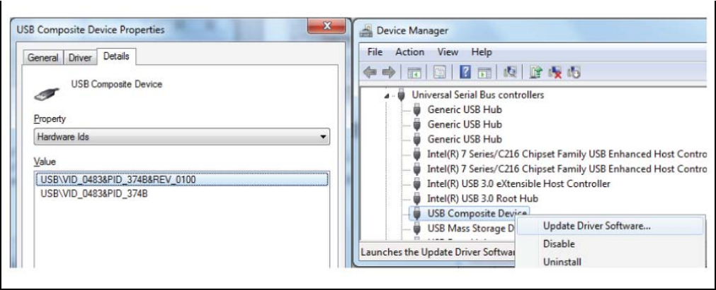

7.4.2 ST-LINK/V2-1 firmware upgrade
The ST-LINK/V2-1 embeds a firmware upgrade mechanism for the in-situ upgrade through the USB port. As the firmware might evolve during the lifetime of the ST-LINK/V2-1 product (for example new functionality, bug fixes, support for new microcontroller families), it is
recommended to visit www.st.com website before starting to use the STM32 Nucleo board and periodically, to stay updated with the latest firmware version.

7.4.3 Mass storage interface
The ST-LINK/V2-1 provides an optional mass storage interface, allowing the user to
program a target application (binary or hex file) through a virtual mass storage disk. The
availability of this interface can be selected during the firmware upgrade, as detailed in the technical note Overview of ST-LINK derivatives (TN1235). Make sure that the host PC
system (including antivirus applications) allows the mass storage disk before activating the interface.

7.4.4 Using the ST-LINK/V2-1 to program and debug the STM32 on board
To program the STM32 on the board, plug in the two jumpers on CN2, as shown in red in Figure 7. Do not use the CN4 connector as this could disturb communication with the
STM32 microcontroller of the STM32 Nucleo board.

18/91 UM1724 Rev 17

Figure 7. Connecting the STM32 Nucleo board to program the on-board STM32

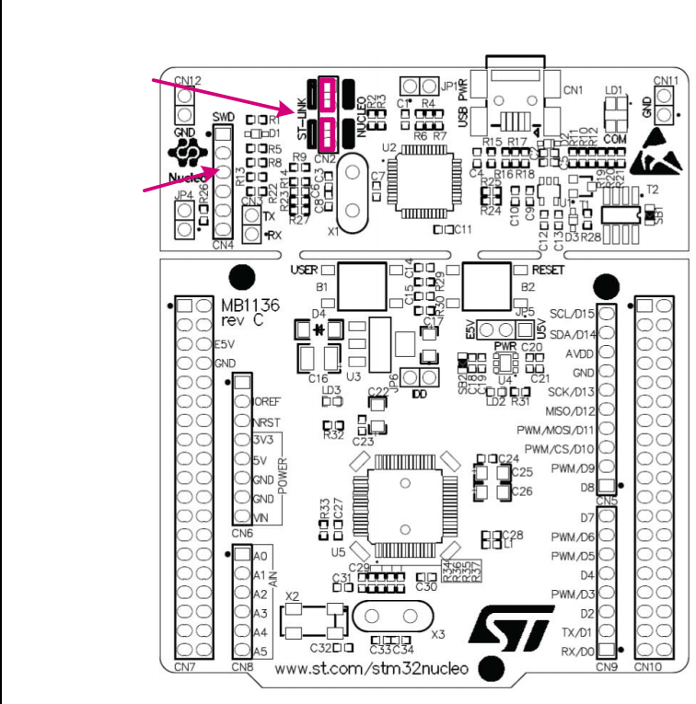  CN4 SWD connector  CN2 jumpers ON | MS34378V2

7.4.5 Using ST-LINK/V2-1 to program and debug an external STM32 application
It is very easy to use the ST-LINK/V2-1 to program the STM32 on an external application. Simply remove the two jumpers from CN2 as illustrated in Figure 8: Using ST-LINK/V2-1 to program the STM32 on an external application, and connect the application to the CN4
debug connector according to Table 5.
Note: SB12 NRST (target STM32 RESET) must be OFF if CN4 pin 5 is used in the external application.

UM1724 Rev 17 19/91

Table 5. Debug connector CN4 (SWD)

Pin | CN4 | Designation
1 | VDD_TARGET | VDD from application
2 | SWCLK | SWD clock
3 | GND | ground
4 | SWDIO | SWD data input/output
5 | NRST | RESET of target STM32
6 | SWO | Reserved

Figure 8. Using ST-LINK/V2-1 to program the STM32 on an external

application

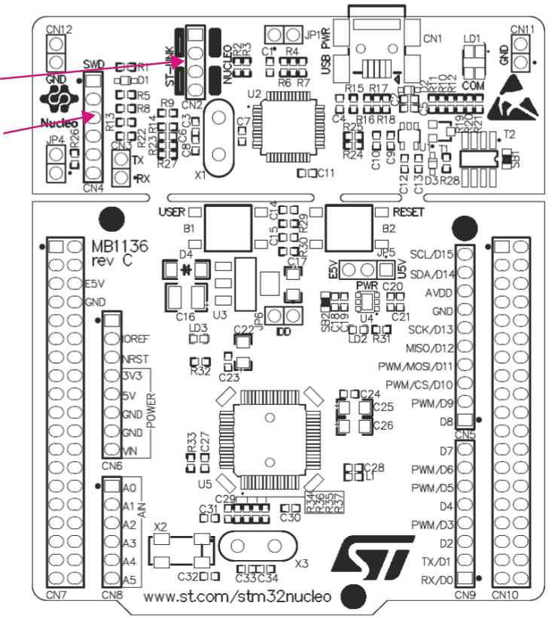
CN2 jumpers OFF

CN4 SWD connector

MS34379V2

20/91 UM1724 Rev 17

7.5 Power supply and power selection
The power supply is provided either by the host PC through the USB cable, or by an
external source: VIN (From 7 V to 12 V), E5V (5 V), or +3.3V power supply pins on CN6 or CN7. In case VIN, E5V, or +3.3V is used to power the STM32 Nucleo board, using an
external power supply unit or auxiliary equipment, this power source must comply with the standard EN-62368-1: 2014/A11:2017, and must be safety extralow voltage (SELV) with limited power capability.

7.5.1 Power supply input from the USB connector
The ST-LINK/V2-1 supports USB power management allowing to request more than
100 mA current to the host PC.
All parts of the STM32 Nucleo board and shield can be powered from the ST-LINK USB
connector CN1 (U5V or VBUS). Note that only the ST-LINK part is power supplied before the USB enumeration as the host PC only provides 100 mA to the board at that time. During the USB enumeration, the STM32 Nucleo board requires 300 mA of current to the host PC. If the host can provide the required power, the targeted STM32 microcontroller is powered and the red LED LD3 is turned ON, thus the STM32 Nucleo board and its shield can
consume a maximum of 300 mA current, not more. If the host is not able to provide the
required current, the targeted STM32 microcontroller and the MCU part including the
extension board are not power supplied. As a consequence, the red LED LD3 remains
turned OFF. In such a case it is mandatory to use an external power supply as explained in the next Section 7.5.2: External power supply inputs: VIN and E5V.
When the board is power supplied by USB (U5V) a jumper must be connected between pin
1 and pin 2 of JP5 as shown in Table 8.
JP1 is configured according to the maximum current consumption of the board when
powered by USB (U5V). JP1 jumper can be set in case the board is powered by USB and maximum current consumption on U5V does not exceed 100 mA (including an eventual
extension board or ARDUINO® shield). In such a condition, USB enumeration always
succeeds since no more than 100 mA is requested from the PC. Possible configurations of JP1 are summarized in Table 6.

Table 6. JP1 configuration table

Jumper state | Power supply | Allowed current
JP1 jumper OFF | USB power through CN1 | 300 mA max
JP1 jumper ON | USB power through CN1 | 100 mA max

Warning: If the maximum current consumption of the NUCLEO and its extension boards exceeds 300 mA, it is mandatory to power the NUCLEO using an external power supply connected to
E5V or VIN.
Note: In case the board is powered by a USB charger, there is no USB enumeration, so the led LD3 remains set to OFF permanently and the target STM32 is not powered. In this specific case, the jumper JP1 needs to be set to ON, to allow target STM32 to be powered anyway.
UM1724 Rev 17 21/91

7.5.2 External power supply inputs: VIN and E5V
The external power sources VIN and E5V are summarized in Table 7. When the board is power supplied by VIN or E5V, the jumper configuration must be the following:
• Jumper on JP5 pin 2 and pin 3
• Jumper removed on JP1

Table 7. External power sources

Input  power name | Connectors  pins | Voltage  range | Max  current | Limitation
VIN | CN6 pin 8  CN7 pin 24 | 7 V to 12 V | 800 mA | From 7 V to 12 V only and input current capability is linked to input voltage:  800 mA input current  when Vin = 7 V  450 mA input current when 7 V < Vin <= 9 V  250 mA input current when 9 V < Vin <= 12 V
E5V | CN7 pin 6 | 4.75 V to  5.25 V | 500 mA | -

Table 8. Power-related jumper

Jumper | Description
JP5 | U5V (ST-LINK VBUS) is used as a power source when JP5 is set as shown below (Default setting)
JP5 |  | E5V  U5V  3 2 1
JP5 | VIN or E5V is used as a power source when JP5 is set as shown below.
JP5 |  | E5V  U5V  3 2 1
Using VIN or E5V as an external power supply
VIN or E5V can be used as an external power supply in case the current consumption of the STM32 Nucleo and extensions boards exceeds the allowed current on USB. In this
condition, it is still possible to use the USB for communication, programming, or debugging only, but it is mandatory to power supply the board first using VIN or E5V and then connect the USB cable to the PC. Proceeding this way ensures that the enumeration occurs thanks to the external power source.
The following power sequence procedure must be respected:

22/91 UM1724 Rev 17

1. Connect the jumper between pin 2 and pin 3 of JP5
2. Check that JP1 is removed
3. Connect the external power source to VIN or E5V
4. Power on the external power supply 7 V< VIN < 12 V to VIN, or 5 V for E5V
5. Check that LD3 is turned ON
6. Connect the PC to USB connector CN1
If this order is not respected, the board might be supplied by VBUS first then by VIN or E5V, and the following risks might be encountered:
1. If more than 300 mA current is needed by the board, the PC might be damaged or the current supply can be limited by the PC. As a consequence, the board is not powered correctly.
2. 300 mA is requested at enumeration (since JP1 must be OFF) so there is a risk that the request is rejected and the enumeration does not succeed if the PC cannot provide
such current. Consequently, the board is not power supplied (LED LD3 remains OFF).

7.5.3 External power supply input: +3.3V
It can be of interest to use the +3.3V (CN6 pin 4 or CN7 pin 12 and pin 16) directly as power input for instance in case the 3.3V is provided by an extension board. When the STM32
Nucleo board is power supplied by +3.3V, the ST-LINK is not powered, thus the
programming and debug features are unavailable. The +3.3V external power source is summarized in Table 9.

Table 9. +3.3 V external power source

Input power  name | Connectors pins | Voltage range | Limitation
+3.3V | CN6 pin 4  CN7 pin 12 and pin 16 | 3 V to 3.6 V | Used when the ST-LINK part of the PCB is cut or SB2 and SB12 OFF
Two different configurations are possible when using +3.3V to power the board:
• ST-LINK is removed (PCB cut) or
• SB2 (3.3V regulator) and SB12 (NRST) are OFF.

7.5.4 External power supply output
When powered by USB, VIN, or E5V, the +5V (CN6 pin 5 or CN7 pin 18) can be used as an output power supply for an ARDUINO® shield or an extension board. In this case, the
maximum current of the power source specified in Table 7 must be respected.
The +3.3V (CN6 pin 4 or CN7 pin 12 and 16) can be used also as power supply output. The current is limited by the maximum current capability of the regulator U4 (500 mA max).

UM1724 Rev 17 23/91

7.6 LEDs
The tricolor LED (green, orange, red) LD1 (COM) provides information about ST-LINK communication status. LD1 default color is red. LD1 turns to green to indicate that
communication is in progress between the PC and the ST-LINK/V2-1, with the following setup:
• Slow blinking Red/Off: at power-on before USB initialization
• Fast blinking Red/Off: after the first correct communication between the PC and ST-LINK/V2-1 (enumeration)
• Red LED On: when the initialization between the PC and ST-LINK/V2-1 is complete
• Green LED On: after a successful target communication initialization
• Blinking Red/Green: during communication with the target
• Green On: communication finished and successful
• Orange On: Communication failure
User LD2: the green LED is a user LED connected to ARDUINO® signal D13 corresponding to STM32 I/O PA5 (pin 21) or PB13 (pin 34) depending on the STM32 target. Refer to
Table 11 to Table 23 when:
• the I/O is HIGH value, the LED is on
• the I/O is LOW, the LED is off
LD3 PWR: the red LED indicates that the STM32 part is powered and +5V power is available.

7.7 Push-buttons
B1 USER: the user button is connected to the I/O PC13 (pin 2) of the STM32
microcontroller.
B2 RESET: this push-button is connected to NRST, and is used to RESET the STM32 microcontroller.
Note: The blue and black plastic hats that are placed on the push-buttons can be removed if
necessary, for example, when a shield or an application board is plugged into the top of the Nucleo board. This will avoid pressure on the buttons and consequently a possible
permanent target STM32 RESET.

7.8 JP6 (IDD)
Jumper JP6, labeled IDD, is used to measure the STM32 microcontroller consumption by removing the jumper and connecting an ammeter:
• Jumper ON: STM32 microcontroller is powered (default).
• Jumper OFF: an ammeter must be connected to measure the STM32 microcontroller current. If there is no ammeter, the STM32 microcontroller is not powered.

24/91 UM1724 Rev 17

7.9 OSC clock

7.9.1 OSC clock supply
There are four ways to configure the pins corresponding to the external high-speed clock (HSE):
• MCO from ST-LINK: MCO output of ST-LINK MCU is used as an input clock. This
frequency cannot be changed, it is fixed at 8 MHz and connected to
PF0/PD0/PH0-OSC_IN of the STM32 microcontroller.
The following configuration is needed:
– SB55 OFF and SB54 ON
– SB16 and SB50 ON
– R35 and R37 removed
• HSE oscillator on-board from X3 crystal (not provided): for typical frequencies and its capacitors and resistors, refer to the STM32 microcontroller datasheet. Refer to the AN2867 Application note for oscillator design guide for STM32 microcontrollers.The X3 crystal has the following characteristics: 8 MHz, 16 pF, 20 ppm, and DIP footprint. It is recommended to use 9SL8000016AFXHF0 manufactured by Hong Kong X'tals
Limited.
The following configuration is needed:
– SB54 and SB55 OFF
– R35 and R37 soldered
– C33 and C34 soldered with 20 pF capacitors
– SB16 and SB50 OFF
• Oscillator from external PF0/PD0/PH0: from an external oscillator through pin 29 of the CN7 connector.
The following configuration is needed:
– SB55 ON
– SB50 OFF
– R35 and R37 removed
• HSE not used: PF0/PD0/PH0 and PF1/PD1/PH1 are used as GPIOs instead of clocks The following configuration is needed:
– SB54 and SB55 ON
– SB16 and SB50 (MCO) OFF
– R35 and R37 removed
There are two possible default configurations of the HSE pins, depending on the version of the STM32 Nucleo board hardware.
The board version MB1136 C-01 or MB1136 C-02 is mentioned on the sticker, placed on the bottom side of the PCB.
The board marking MB1136 C-01 corresponds to a board, configured as HSE not used. The board marking MB1136 C-02 (or higher) corresponds to a board, configured to use ST-LINK MCO as the clock input.

UM1724 Rev 17 25/91

Note: For NUCLEO-L476RG and NUCLEO-L452RE the ST-LINK MCO output is not connected to OSCIN to reduce power consumption in low power mode. Consequently, NUCLEO-L476RG and NUCLEO-L452RE configurations correspond to HSE not used.

7.9.2 OSC 32 KHz clock supply
There are three ways to configure the pins corresponding to the low-speed clock (LSE):
• On-board oscillator: X2 crystal. Refer to the Oscillator design guide for STM8S,
STM8A and STM32 microcontrollers application note (AN2867) for oscillator design guide for STM32 microcontrollers. It is recommended to use ABS25-32.768KHZ-6-T, manufactured by Abracon Corporation.
• Oscillator from external PC14: from external oscillator through the pin 25 of CN7 connector.
The following configuration is needed:
– SB48 and SB49 ON
– R34 and R36 removed
• LSE not used: PC14 and PC15 are used as GPIOs instead of low-speed clocks. The following configuration is needed:
– SB48 and SB49 ON
– R34 and R36 removed
There are three possible default configurations of the LSE depending on the version of the STM32 Nucleo board hardware.
The board version MB1136 C-01 or MB1136 C-02 is mentioned on the sticker placed on the bottom side of the PCB.
The board marking MB1136 C-01 corresponds to a board configured as LSE not used.
The board marking MB1136 C-02 (or higher) corresponds to a board configured with an on- board 32 KHz oscillator.
The board marking MB1136 C-03 (or higher) corresponds to a board using a new LSE crystal (ABS25) and C26, C3 1, and C32 value update.

7.10 USART communication
The USART2 interface available on PA2 and PA3 of the STM32 microcontroller can be
connected to ST-LINK MCU, ST morpho connector, or ARDUINO® connector. The choice can be changed by setting the related solder bridges. By default, the USART2
communication between the target STM32 and ST-LINK MCU is enabled, to support virtual COM port (SB13 and SB14 ON, SB62 and SB63 OFF). If the communication between the target STM32 PA2 (D1) or PA3 (D0) and shield or extension board is required, SB62 and SB63 must be ON, while SB13 and SB14 must be OFF. In such a case, it is possible to
connect another USART to the ST-LINK MCU using flying wires between the ST morpho connector and CN3. For instance, on NUCLEO-F103RB it is possible to use USART3
available on PC10 (TX) and PC11 (RX). Two flying wires need to be connected as follows:
• PC10 (USART3_TX) available on CN7 pin 1 to CN3 pin RX
• PC11 (USART3_RX) available on CN7 pin 2 to CN3 pin TX

26/91 UM1724 Rev 17

7.11 Solder bridges

Table 10. Solder
bridges

Bridge | State(1) | Description
SB54, SB55 (X3 crystal)(2) | OFF | X3, C33, C34, R35, and R37 provide a clock as shown in electrical  schematics PF0/PD0/PH0, PF1/PD1/PH1 are disconnected from CN7.
SB54, SB55 (X3 crystal)(2) | ON | PF0/PD0/PH0 and PF1/PD1/PH1 are connected to CN7. (R35, R37, and SB50 must not be fitted).
SB3, SB5, SB7,SB9  (DEFAULT) | ON | Reserved, do not modify.
SB4,SB6, SB8,SB10  (RESERVED) | OFF | Reserved, do not modify.
SB48, SB49  (X2 crystal)(3) | OFF | X2, C31, C32, R34, and R36 deliver a 32 KHz clock. PC14 and PC15 are not connected to CN7.
SB48, SB49  (X2 crystal)(3) | ON | PC14 and PC15 are only connected to CN7. Remove only R34 and R36.
SB17  (B1-USER) | ON | B1 push button is connected to PC13.
SB17  (B1-USER) | OFF | B1 push button is not connected to PC13.
SB12 (NRST) | ON | The NRST signal of the CN4 connector is connected to the NRST pin of the STM32.
SB12 (NRST) | OFF | The NRST signal of the CN4 connector is not connected to the NRST pin of the STM32.
SB15 (SWO) | ON | The SWO signal of the CN4 connector is connected to PB3.
SB15 (SWO) | OFF | The SWO signal is not connected.
SB11 (STM_RST) | OFF | No incidence on STM32F103CBT6 (ST-LINK MCU) NRST signal.
SB11 (STM_RST) | ON | STM32F103CBT6 (ST-LINK MCU) NRST signal is connected to GND.
SB1 (USB-5V) | OFF | USB power management is functional.
SB1 (USB-5V) | ON | USB power management is disabled.
SB2 (3.3 V) | ON | Output of voltage regulator LD39050PU33R is connected to 3.3V.
SB2 (3.3 V) | OFF | Output of voltage regulator LD39050PU33R is not connected.
SB21 (LD2-LED) | ON | Green user LED LD2 is connected to D13 of ARDUINO® signal.
SB21 (LD2-LED) | OFF | Green user LED LD2 is not connected.
SB56,SB51 (A4 andA5) | ON | PC1 and PC0 (ADC in) are connected toA4 andA5 (pin 5 and pin 6) on  ARDUINO® connector CN8 and ST morpho connector CN7. Thus SB46 and  SB52 must be OFF.
SB56,SB51 (A4 andA5) | OFF | PC1 and PC0 (ADC in) are disconnected toA4 andA5 (pin 5 and pin 6) on  ARDUINO® connector CN8 and ST morpho connector CN7.
SB46,SB52  (I2C on A4 andA5) | OFF | PB9 and PB8 (I2C) are disconnected to A4 and A5 (pin 5 and pin 6) on  ARDUINO® connector CN8 and ST morpho connector CN7.
SB46,SB52  (I2C on A4 andA5) | ON | PB9 and PB8 (I2C) are connected to A4 and A5 (pin 5 and pin 6) on  ARDUINO® connector CN8 and ST morpho connector CN7 as I2C signals.  Thus SB56 and SB51 must be OFF.

UM1724 Rev 17 27/91

Table 10. Solder bridges (continued)

Bridge | State(1) | Description
SB45 (VBAT/VLCD) | ON | VBAT or VLCD on STM32 is connected to VDD.
SB45 (VBAT/VLCD) | OFF | VBAT or VLCD on STM32 is not connected to VDD.
SB57 (VDDA/VREF+) | ON | VDDA/VREF+ on STM32 is connected to VDD.
SB57 (VDDA/VREF+) | OFF | VDDA/VREF+ on STM32 is not connected to VDD and can be provided from  pin 8 of CN5 (Used for external VREF+ provided by ARDUINO® shield)
SB62, SB63 (USART) | OFF | PA2 and PA3 on STM32 are disconnected to D1 and D0 (pin 2 and pin 1) on  ARDUINO® connector CN9 and ST morpho connector CN10.
SB62, SB63 (USART) | ON | PA2 and PA3 on STM32 are connected to D1 and D0 (pin 2 and pin 1) on  ARDUINO® connector CN9 and ST morpho connector CN10 as USART  signals. Thus SB13 and SB14 must be OFF.
SB13, SB14  (ST-LINK-USART) | ON | PA2 and PA3 on STM32F103CBT6 (ST-LINK MCU) are connected to PA3 and PA2 on STM32 to have USART communication between them. Thus SB61, SB62, and SB63 must be OFF.
SB13, SB14  (ST-LINK-USART) | OFF | PA2 and PA3 on STM32F103CBT6 (ST-LINK MCU) are disconnected to PA3 and PA2 on STM32.
SB16,SB50(MCO)(2) | OFF | MCO on STM32F103CBT6 (ST-LINK MCU) are disconnected to PF0/PD0/PH0 on STM32.
SB16,SB50(MCO)(2) | ON | MCO on STM32F103CBT6 (ST-LINK MCU) are connected to PF0/PD0/PH0 on STM32.
1. The default SBx state is shown in bold.
2. The default configuration depends on the board version. Refer to Section 7.9.1: OSC clock supply for details.
3. The default configuration depends on the board version. Refer to Section 7.9.2: OSC 32 KHz clock supply for details.

All the other solder bridges present on the STM32 Nucleo board are used to configure several I/Os and power supply pins for compatibility of features and pinout with STM32 supported.
All STM32 Nucleo boards are delivered with the solder-bridges configured according to the target supported STM32.

28/91 UM1724 Rev 17

7.12 Extension connectors
Figure 9 to Figure 25 show the signals connected by default to ARDUINO® Uno V3
connectors (CN5, CN6, CN8, CN9) and to ST morpho connector (CN7 and CN10), for each STM32 Nucleo board.

Figure 9. NUCLEO.F030R8

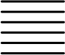
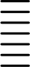
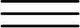
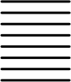
NUCLEO-F030R8
PC9 PB8 PB9 AVDD GND PA5 PA6 PA7 PB6 PC7 PA9
PA8 PB10 PB4 PB5 PB3 PA10 PA2 PA3
PC11
PD2
E5V
GND
NC
IOREF RESET +3V3
+5V GND GND VIN NC
PA0 PA1 PA4 PB0 PC1 PC0
PC8
PC6
PC5
U5V
NC
PA12 PA11 PB12 PB11 GND
PB2
PB1
PB15 PB14 PB13 AGND PC4
PF5 PF4
PC10 PC12 VDD BOOT0
PF6 PF7 PA13 PA14 PA15 GND PB7 PC13 PC14 PC15 PF0 PF1 VBAT PC2 PC3
D15 D14 AVDD GND D13 D12 D11 D10 D9 D8
D7 D6
D5 D4
D3 D2
D1 D0
NC
IOREF RESET +3V3
+5V GND GND VIN
A0 A1
A2 A3
A4 A5

1
2
3
4
5
6

CN5 CN10
 |  | 1 | 2
10 |  | 1 | 2
10 |  | 3 | 4
9 |  | 3 | 4
9 |  | 5 | 6
8 |  | 5 | 6
8 |  | 7 | 8
7 |  | 7 | 8
7 |  | 9 | 10
6 |  | 9 | 10
6 |  | 11 | 12
5 |  | 11 | 12
5 |  | 13 | 14
4 |  | 13 | 14
4 |  | 15 | 16
3 |  | 15 | 16
3 |  | 17 | 18
2 |  | 17 | 18
2 |  | 19 | 20
1 |  | 19 | 20
 |  | 21 | 22
8 |  | 23 | 24
7 |  | 25 | 26
6 |  | 27 | 28
5 |  | 29 | 30
4 |  | 31 | 32
3 |  | 33 | 34
2 |  | 35 | 36
1 |  | 37 | 38

CN7 CN6

1 | 2
3 | 4
5 | 6
7 | 8
9 | 10
11 | 12
13 | 14
15 | 16
17 | 18
19 | 20
21 | 22
23 | 24
25 | 26
27 | 28
29 | 30
31 | 32
33 | 34
35 | 36
37 | 38

1
2
3
4
5
6
7
8

CN8 CN9
口 Arduino 口 Morpho
MSv34385V3

Figure 10. NUCLEO.F070RB

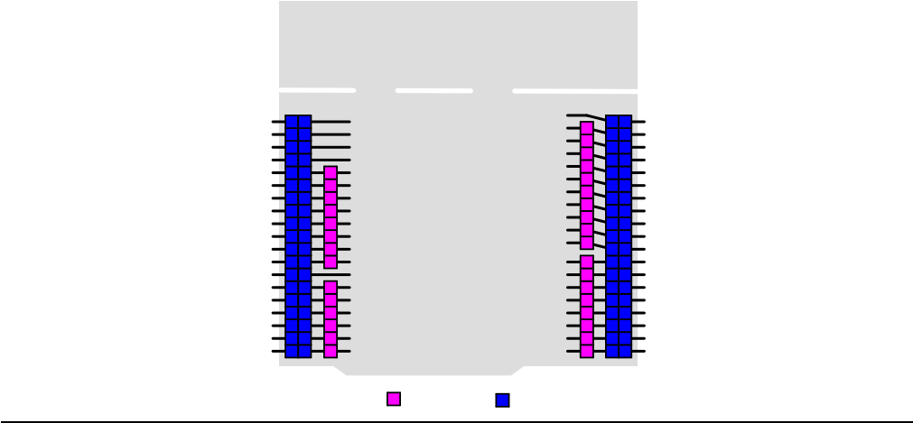
PC8 PC6 PC5 U5V NC
PA12
PA11
PB12
PB11
GND PB2
PB1
PB15
PB14
PB13
AGND PC4
NC NC

MSv36554V1
PC9
PB8
PB9
AVDD
GND
PA5
PA6
PA7
PB6
PC7
PA9
PA8
PB10
PB4
PB5
PB3
PA10
PA2
PA3

Morpho
NC
IOREF RESET +3V3
+5V
GND
GND
VIN
A0
A1
A2
A3
A4
A5

Arduino
PC10
PC12
VDD BOOT0 NC
NC
PA13
PA14
PA15
GND
PB7
PC13
PC14
PC15
PF0
PF1
VDD
PC2
PC3
PC11
PD2
E5V
GND
NC
IOREF RESET +3V3
+5V
GND
GND
VIN
NC
PA0
PA1
PA4
PB0
PC1
PC0
D15
D14
AVDD
GND
D13
D12
D11
D10
D9
D8
D7
D6
D5
D4
D3
D2
D1
D0
CN6

1
2
3
4
5
6
7
8
1
2
3
4
5
6
CN8
CN7
1 2
3 4
5 6
7 8
9 10
11 12
13 14
15 16
17 18
19 20
21 22
23 24
25 26
27 28
29 30
31 32
33 34
35 36
37 38
10
9
8
7
6
5
4
3
2
1
8
7
6
5
4
3
2
1
CN9
NUCLEO-F070RB
1
3
5
7
9
11
13
15
17
19
21
23
25
27
29
31
33
35
37
2
4
6
8
10
12
14
16
18
20
22
24
26
28
30
32
34
36
38
CN5 CN10

UM1724 Rev 17 29/91

Figure 11. NUCLEO.F072RB

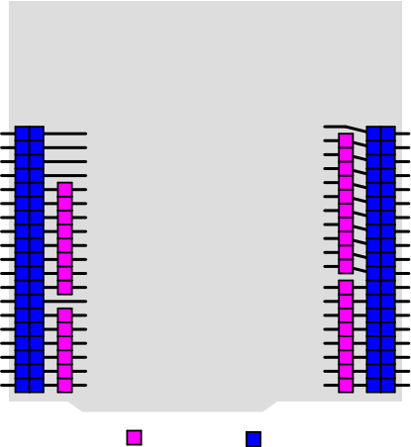  Arduino  PC10  PC12  VDD BOOT0 NC  NC  PA13  PA14  PA15  GND  PB7  PC13  PC14  PC15  PF0  PF1  VBAT  PC2  PC3  PC11  PD2  E5V  GND  NC  IOREF RESET +3V3  +5V  GND  GND  VIN  NC  PA0  PA1  PA4  PB0  PC1  PC0  PC9  PB8  PB9  AVDD  GND  PA5  PA6  PA7  PB6  PC7  PA9  PA8  PB10  PB4  PB5  PB3  PA10  PA2  PA3  PC8  PC6  PC5  U5V  NC  PA12  PA11  PB12  PB11  GND  PB2  PB1  PB15  PB14  PB13  AGND  PC4  NC  NC  D15  D14  AVDD  GND  D13  D12  D11  D10  D9  D8  D7  D6  D5  D4  D3  D2  D1  D0  NC  IOREF RESET +3V3  +5V  GND  GND  VIN  A0  A1  A2  A3  A4  A5  CN6  1  2  3  4  5  6  7  8  1  2  3  4  5  6  CN8  CN7  1 2  3 4  5 6  7 8  9 10  11 12  13 14  15 16  17 18  19 20  21 22  23 24  25 26  27 28  29 30  31 32  33 34  35 36  37 38  10  9  8  7  6  5  4  3  2  1  8  7  6  5  4  3  2  1  CN9  NUCLEO-F072RB  1  3  5  7  9  11  13  15  17  19  21  23  25  27  29  31  33  35  37  2  4  6  8  10  12  14  16  18  20  22  24  26  28  30  32  34  36  38  CN5 CN10  Morpho | MSv34386V3

Figure 12. NUCLEO.F091RC

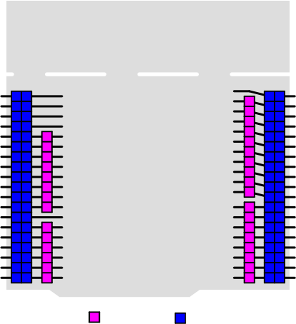  Arduino  PC10  PC12  VDD  PF11-BOOT0 NC  NC  PA13  PA14  PA15  GND  PB7  PC13  PC14  PC15  PF0  PF1  VBAT  PC2  PC3  PC11  PD2  E5V  GND  NC  IOREF RESET +3V3  +5V  GND  GND  VIN  NC  PA0  PA1  PA4  PB0  PC1  PC0  PC9  PB8  PB9  AVDD  GND  PA5  PA6  PA7  PB6  PC7  PA9  PA8  PB10  PB4  PB5  PB3  PA10  PA2  PA3  PC8  PC6  PC5  U5V  NC  PA12  PA11  PB12  PB11  GND  PB2  PB1  PB15  PB14  PB13  AGND  PC4  NC  NC  D15  D14  AVDD  GND  D13  D12  D11  D10  D9  D8  D7  D6  D5  D4  D3  D2  D1  D0  NC  IOREF RESET +3V3  +5V  GND  GND  VIN  A0  A1  A2  A3  A4  A5  CN6  1  2  3  4  5  6  7  8  1  2  3  4  5  6  CN8  CN7  1 2  3 4  5 6  7 8  9 10  11 12  13 14  15 16  17 18  19 20  21 22  23 24  25 26  27 28  29 30  31 32  33 34  35 36  37 38  10  9  8  7  6  5  4  3  2  1  8  7  6  5  4  3  2  1  CN9  NUCLEO-F091RC  1  3  5  7  9  11  13  15  17  19  21  23  25  27  29  31  33  35  37  2  4  6  8  10  12  14  16  18  20  22  24  26  28  30  32  34  36  38  CN5 CN10  Morpho | MSv35752V1

30/91 UM1724 Rev 17

Figure 13. NUCLEO.F103RB

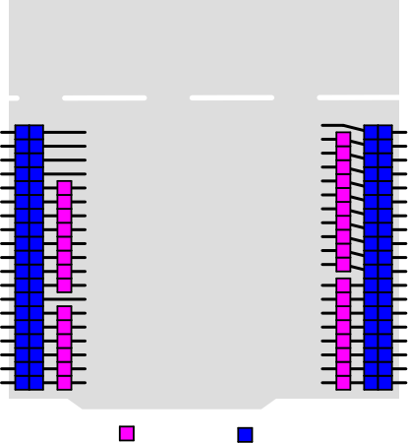  Arduino  PC10  PC12  VDD BOOT0 NC  NC  PA13  PA14  PA15  GND  PB7  PC13  PC14  PC15  PD0  PD1  VBAT  PC2  PC3  PC11  PD2  E5V  GND  NC  IOREF RESET +3V3  +5V  GND  GND  VIN  NC  PA0  PA1  PA4  PB0  PC1  PC0  PC9  PB8  PB9  AVDD  GND  PA5  PA6  PA7  PB6  PC7  PA9  PA8  PB10  PB4  PB5  PB3  PA10  PA2  PA3  PC8  PC6  PC5  U5V  NC  PA12  PA11  PB12  PB11  GND  PB2  PB1  PB15  PB14  PB13  AGND  PC4  NC  NC  D15  D14  AVDD  GND  D13  D12  D11  D10  D9  D8  D7  D6  D5  D4  D3  D2  D1  D0  NC  IOREF RESET +3V3  +5V  GND  GND  VIN  A0  A1  A2  A3  A4  A5  CN6  1  2  3  4  5  6  7  8  1  2  3  4  5  6  CN8  CN7  1 2  3 4  5 6  7 8  9 10  11 12  13 14  15 16  17 18  19 20  21 22  23 24  25 26  27 28  29 30  31 32  33 34  35 36  37 38  10  9  8  7  6  5  4  3  2  1  8  7  6  5  4  3  2  1  CN9  NUCLEO-F103RB  2  4  6  8  10  12  14  16  18  20  22  24  26  28  30  32  34  36  38  1  3  5  7  9  11  13  15  17  19  21  23  25  27  29  31  33  35  37  CN5 CN10  Morpho | MSv34382V3

Figure 14. NUCLEO.F302R8

PC10 PC12 VDD BOOT0  NC NC PA13 PA14 PA15 GND PB7 PC13 PC14 PC15 PF0 PF1 VBAT PC2 PC3 | 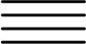  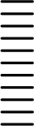  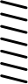  34  33  CN5 CN10  CN9  PC9 PB8 PB9 AVDD GND PB13 PB14 PB15 PB6 PC7 PA9  PA8 PB10 PB4 PB5 PB3 PA10 PA2 PA3  PC11  PD2  E5V  GND  NC  IOREF RESET +3V3  +5V GND GND VIN NC  PA0 PA1 PA4 PB0 PC1 PC0  D15 D14 AVDD GND D13 D12 D11 D10 D9 D8  D7 D6  D5 D4  D3 D2  D1 D0  NC  IOREF RESET +3V3  +5V GND GND VIN  A0 A1  A2 A3  A4 A5    NUCLEO-F302R8  CN7 CN6  CN8 |  | PC8  PC6  PC5  U5V  NC  PA12 PA11 PB12 PB11 GND  PB2  PB1  PA7  PA6  PA5  AGND PC4  NC NC
  10
  9
  8
  7
  6
  5
  4
  3
  2
  1
  8
  7
  6
  5
  4
  3
  2
  1
  1 | 2
  3 | 4
  5 | 6
  7 | 8
  9 | 10
  11 | 12
  13 | 14
  15 | 16
  17 | 18
  19 | 20
  21 | 22
  23 | 24
  25 | 26
  27 | 28
  29 | 30
  31 | 32
  33 | 34
  35 | 36
  37 | 38
   | 1 | 2
   | 3 | 4
   | 5 | 6
   | 7 | 8
   |  |  |  | 1
   | 9 | 10
   |  |  |  | 2
   | 11 | 12
   |  |  |  | 3
   | 13 | 14
   |  |  |  | 4
   | 15 | 16
   |  |  |  | 5
   | 17 | 18
   |  |  |  | 6
   | 19 | 20
   |  |  |  | 7
   | 21 | 22
   |  |  |  | 8
   | 23 | 24
   | 25 | 26
   |  |  |  | 1
   | 27 | 28
   |  |  |  | 2
   | 29 | 30
   |  |  |  | 3
   | 31 | 32
   |  |  |  | 4
   |  |  |  | 5
   | 35 | 36
   |  |  |  | 6
   | 37 | 38
口 Arduino 口 |  | Morpho  MSv34931V3

UM1724 Rev 17 31/91

Figure 15. NUCLEO.F303RE

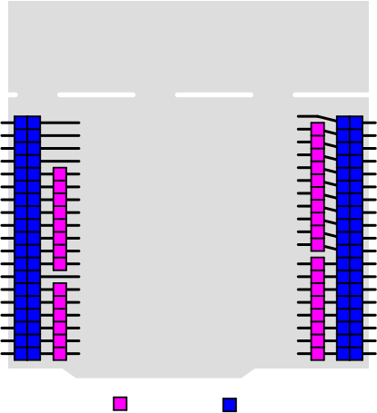  Arduino  PC10  PC12  VDD BOOT0 NC  NC  PA13  PA14  PA15  GND  PB7  PC13  PC14  PC15  PF0  PF1  VBAT  PC2  PC3  PC11  PD2  E5V  GND  NC  IOREF RESET +3V3  +5V  GND  GND  VIN  NC  PA0  PA1  PA4  PB0  PC1  PC0  PC9  PB8  PB9  AVDD  GND  PA5  PA6  PA7  PB6  PC7  PA9  PA8  PB10  PB4  PB5  PB3  PA10  PA2  PA3  PC8  PC6  PC5  U5V  NC  PA12  PA11  PB12  PB11  GND  PB2  PB1  PB15  PB14  PB13  AGND  PC4  NC  NC  D15  D14  AVDD  GND  D13  D12  D11  D10  D9  D8  D7  D6  D5  D4  D3  D2  D1  D0  NC  IOREF RESET +3V3  +5V  GND  GND  VIN  A0  A1  A2  A3  A4  A5  CN6  1  2  3  4  5  6  7  8  1  2  3  4  5  6  CN8  CN7  1 2  3 4  5 6  7 8  9 10  11 12  13 14  15 16  17 18  19 20  21 22  23 24  25 26  27 28  29 30  31 32  33 34  35 36  37 38  10  9  8  7  6  5  4  3  2  1  8  7  6  5  4  3  2  1  CN9  NUCLEO-F303RE  1  3  5  7  9  11  13  15  17  19  21  23  25  27  29  31  33  35  37  2  4  6  8  10  12  14  16  18  20  22  24  26  28  30  32  34  36  38  CN5 CN10  Morpho | MSv35753V1

Figure 16. NUCLEO.F334R8

PC10 PC12 VDD BOOT0  NC NC PA13 PA14 PA15 GND PB7 PC13 PC14 PC15 PF0 PF1 VBAT PC2 PC3 | 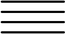  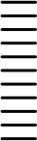  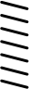  34  33  CN5 CN10  CN9  PC9 PB8 PB9 AVDD GND PA5 PA6 PA7 PB6 PC7 PA9  PA8 PB10 PB4 PB5 PB3 PA10 PA2 PA3  PC11  PD2  E5V  GND  NC  IOREF RESET +3V3  +5V GND GND VIN NC  PA0 PA1 PA4 PB0 PC1 PC0  D15 D14 AVDD GND D13 D12 D11 D10 D9 D8  D7 D6  D5 D4  D3 D2  D1 D0  NC  IOREF RESET +3V3  +5V GND GND VIN  A0 A1  A2 A3  A4 A5    NUCLEO-F334R8  CN7 CN6  CN8 |  | PC8  PC6  PC5  U5V  NC  PA12 PA11 PB12 PB11 GND  PB2  PB1  PB15 PB14 PB13 AGND PC4  NC NC
  10
  9
  8
  7
  6
  5
  4
  3
  2
  1
  8
  7
  6
  5
  4
  3
  2
  1
  1 | 2
  3 | 4
  5 | 6
  7 | 8
  9 | 10
  11 | 12
  13 | 14
  15 | 16
  17 | 18
  19 | 20
  21 | 22
  23 | 24
  25 | 26
  27 | 28
  29 | 30
  31 | 32
  33 | 34
  35 | 36
  37 | 38
   | 1 | 2
   | 3 | 4
   | 5 | 6
   | 7 | 8
   |  |  |  | 1
   | 9 | 10
   |  |  |  | 2
   | 11 | 12
   |  |  |  | 3
   | 13 | 14
   |  |  |  | 4
   | 15 | 16
   |  |  |  | 5
   | 17 | 18
   |  |  |  | 6
   | 19 | 20
   |  |  |  | 7
   | 21 | 22
   |  |  |  | 8
   | 23 | 24
   | 25 | 26
   |  |  |  | 1
   | 27 | 28
   |  |  |  | 2
   | 29 | 30
   |  |  |  | 3
   | 31 | 32
   |  |  |  | 4
   |  |  |  | 5
   | 35 | 36
   |  |  |  | 6
   | 37 | 38
口 Arduino 口 |  | Morpho  MSv34932V3

32/91 UM1724 Rev 17

Figure 17. NUCLEO.F401RE

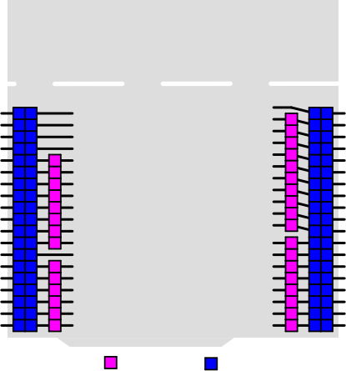  NUCLEO-F401RE  PC10  CN5 CN10  CN7  1 2  3 4  5 6  7 8  9 10  11 12  13 14  15 16  17 18  19 20  21 22  23 24  25 26  27 28  29 30  31 32  33 34  35 36  37 38  CN6  PC8  PC9  PC11  PD2  E5V  GND  NC  IOREF RESET +3V3  +5V  GND  GND  VIN  NC  PA0  PA1  PA4  PB0  PC1  PC0  2  4  6  8  10  12  14  16  18  20  22  24  26  28  30  32  34  36  38  1  3  5  7  9  11  13  15  17  19  21  23  25  27  29  31  33  35  37  D15  PB8  10  9  8  7  PC12  PC6  PB9  VDD BOOT0 NC  D14  PC5  AVDD  AVDD  U5V  GND  GND  NC  IOREF RESET +3V3  +5V  GND  GND  VIN  A0  A1  A2  A3  A4  A5  NC  1  2  3  4  5  6  7  8  1  2  3  4  5  6  D13  PA5  6  NC  PA12  PA6  PA13  5  4  3  2  D12  PA11  D11  PA7  PA14  PB12  D10  PB6  PA15  NC  D9  PC7  GND  GND  D8  PA9  1  PB7  PB2  PC13  PA8  D7  PB1  8  7  6  5  4  3  2  1  CN9  PC14  D6  PB15  PB10  PC15  D5  PB14  PB4  PH0  PB5  PB13  D4  PH1  D3  AGND  PB3  VBAT  PA10  PC4  D2  PC2  NC  D1  PA2  PC3  D0  PA3  NC  CN8  Arduino Morpho | MSv34384V3

Figure 18. NUCLEO.F411RE

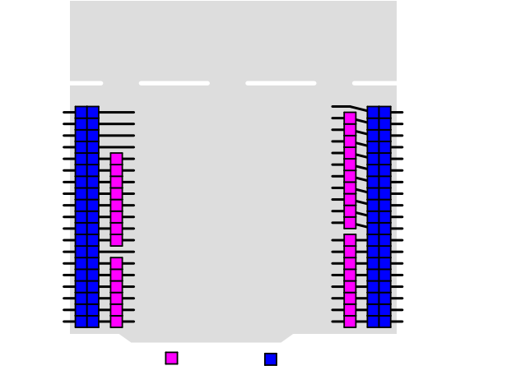  NUCLEO-F411RE  PC10  CN5 CN10  CN7  1 2  3 4  5 6  7 8  9 10  11 12  13 14  15 16  17 18  19 20  21 22  23 24  25 26  27 28  29 30  31 32  33 34  35 36  37 38  CN6  PC9  PC8  PC11  PD2  E5V  GND  NC  IOREF RESET +3V3  +5V  GND  GND  VIN  NC  PA0  PA1  PA4  PB0  PC1  PC0  2  4  6  8  10  12  14  16  18  20  22  24  26  28  30  32  34  36  38  1  3  5  7  9  11  13  15  17  19  21  23  25  27  29  31  33  35  37  D15  PB8  10  9  8  7  PC12  PC6  PB9  VDD BOOT0 NC  D14  PC5  AVDD  AVDD  U5V  GND  GND  NC  IOREF RESET +3V3  +5V  GND  GND  VIN  A0  A1  A2  A3  A4  A5  NC  1  2  3  4  5  6  7  8  1  2  3  4  5  6  D13  PA5  6  NC  PA12  PA6  PA13  5  4  3  2  D12  PA11  D11  PA7  PA14  PB12  D10  PB6  PA15  NC  D9  PC7  GND  GND  D8  PA9  1  PB7  PB2  PC13  PA8  D7  PB1  8  7  6  5  4  3  2  1  CN9  PC14  D6  PB10  PB15  PC15  D5  PB14  PB4  PH0  PB5  PB13  D4  PH1  D3  PB3  AGND  VBAT  PA10  PC4  D2  PC2  NC  D1  PA2  PC3  D0  PA3  NC  CN8  Arduino Morpho | MSv34933V3

UM1724 Rev 17 33/91

Figure 19. NUCLEO.L053R8

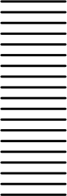
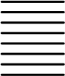
NUCLEO-L053R8
PC9 PB8 PB9 AVDD GND PA5 PA6 PA7 PB6 PC7 PA9
PA8 PB10 PB4 PB5 PB3 PA10 PA2 PA3
PC8
PC6
PC5
U5V
NC
PA12
PA11
PB12
PB11
GND
PB2
PB1
PB15 PB14 PB13 AGND PC4
NC NC
PC11
PD2
E5V
GND
NC
IOREF RESET +3V3
+5V GND GND VIN NC
PA0 PA1 PA4 PB0 PC1 PC0
PC10 PC12 VDD BOOT0
NC NC PA13 PA14 PA15 GND PB7 PC13 PC14 PC15 PH0 PH1 VLCD PC2 PC3
D15 D14 AVDD GND D13 D12 D11 D10 D9 D8
D7 D6
D5 D4
D3 D2
D1 D0
NC
IOREF RESET +3V3
+5V GND GND VIN
A0 A1
A2 A3
A4 A5

8
7
6
5
4
3
2
1

CN8 CN9
CN5 CN10

1 | 2
3 | 4
5 | 6
7 | 8
9 | 10
11 | 12
13 | 14
15 | 16
17 | 18
19 | 20
21 | 22
23 | 24
25 | 26
27 | 28
29 | 30
31 | 32
33 | 34
35 | 36
37 | 38

CN7 CN6

1 | 2
3 | 4
5 | 6
7 | 8
9 | 10
11 | 12
13 | 14
15 | 16
17 | 18
19 | 20
21 | 22
23 | 24
25 | 26
27 | 28
29 | 30
31 | 32
33 | 34
35 | 36
37 | 38

10
9
8
7
6
5
4
3
2
1

1
2
3
4
5
6
7
8
1
2
3
4
5
6

口 Arduino 口 | Morpho
 | MSv34934V3

Figure 20. NUCLEO.L073RZ and NUCLEO.L010RB

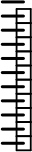
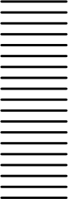
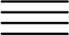
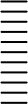

NUCLEO-L073RZ
NUCLEO-L010RB
PC9 PB8 PB9 AVDD GND PA5 PA6 PA7 PB6 PC7 PA9
PA8 PB10 PB4 PB5 PB3 PA10 PA2 PA3
PC8
PC6
PC5
U5V
NC
PA12 PA11 PB12 PB11 GND
PB2
PB1
PB15 PB14 PB13 AGND PC4
NC NC
PC11
PD2
E5V
GND
NC
IOREF RESET +3V3
+5V GND GND VIN NC
PA0 PA1 PA4 PB0 PC1 PC0
PC10 PC12 VDD
NC NC PA13 PA14 PA15 GND PB7 PC13 PC14 PC15 PH0 PH1 VLCD PC2 PC3
D15 D14 AVDD GND D13 D12 D11 D10 D9 D8
D7 D6
D5 D4
D3 D2
D1 D0
NC
IOREF RESET +3V3
+5V GND GND VIN
A0 A1
A2 A3
A4 A5
CN8 CN9
CN5 CN10

1 | 2
3 | 4
5 | 6
7 | 8
9 | 10
11 | 12
13 | 14
15 | 16
17 | 18
19 | 20
21 | 22
23 | 24
25 | 26
27 | 28
29 | 30
31 | 32
33 | 34
35 | 36
37 | 38

CN7 CN6

1 | 2
3 | 4
5 | 6
7 | 8
9 | 10
11 | 12
13 | 14
15 | 16
17 | 18
19 | 20
21 | 22
23 | 24
25 | 26
27 | 28
29 | 30
31 | 32
33 | 34
35 | 36
37 | 38

10
9
8
7
6
5
4
3
2
1
1
2
3
4
5
6
7
8
1
2
3
4
5
6

8
7
6
5
4
3
2
1

口 Arduino 口
Morpho
MSv49223V1

34/91 UM1724 Rev 17

Figure 21. NUCLEO.L152RE

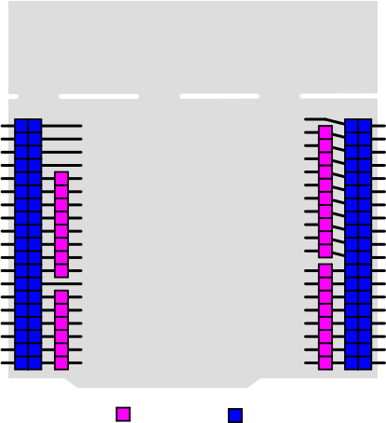  Arduino  PC10  PC12  VDD BOOT0 NC  NC  PA13  PA14  PA15  GND  PB7  PC13  PC14  PC15  PH0  PH1  VLCD  PC2  PC3  PC11  PD2  E5V  GND  NC  IOREF RESET +3V3  +5V  GND  GND  VIN  NC  PA0  PA1  PA4  PB0  PC1  PC0  PC9  PB8  PB9  AVDD  GND  PA5  PA6  PA7  PB6  PC7  PA9  PA8  PB10  PB4  PB5  PB3  PA10  PA2  PA3  PC8  PC6  PC5  U5V  NC  PA12  PA11  PB12  PB11  GND  PB2  PB1  PB15  PB14  PB13  AGND  PC4  NC  NC  D15  D14  AVDD  GND  D13  D12  D11  D10  D9  D8  D7  D6  D5  D4  D3  D2  D1  D0  NC  IOREF RESET +3V3  +5V  GND  GND  VIN  A0  A1  A2  A3  A4  A5  CN6  1  2  3  4  5  6  7  8  1  2  3  4  5  6  CN8  CN7  1 2  3 4  5 6  7 8  9 10  11 12  13 14  15 16  17 18  19 20  21 22  23 24  25 26  27 28  29 30  31 32  33 34  35 36  37 38  10  9  8  7  6  5  4  3  2  1  8  7  6  5  4  3  2  1  CN9  NUCLEO-L152RE  1  3  5  7  9  11  13  15  17  19  21  23  25  27  29  31  33  35  37  2  4  6  8  10  12  14  16  18  20  22  24  26  28  30  32  34  36  38  CN5 CN10  Morpho | MSv34383V3

Figure 22. NUCLEO.L452RE

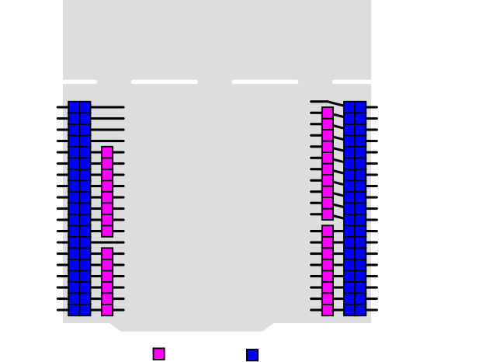  NUCLEO-L452RE  PC10  CN5 CN10  CN7  1 2  3 4  5 6  7 8  9 10  11 12  13 14  15 16  17 18  19 20  21 22  23 24  25 26  27 28  29 30  31 32  33 34  35 36  37 38  CN6  PC8  PC9  PC11  PD2  E5V  GND  NC  IOREF RESET +3V3  +5V  GND  GND  VIN  NC  PA0  PA1  PA4  PB0  PC1  PC0  2  4  6  8  10  12  14  16  18  20  22  24  26  28  30  32  34  36  38  1  3  5  7  9  11  13  15  17  19  21  23  25  27  29  31  33  35  37  D15  PB8  10  9  8  7  PC12  PC6  PB9  VDD BOOT0 NC  D14  PC5  AVDD  AVDD  U5V  GND  GND  NC  IOREF RESET +3V3  +5V  GND  GND  VIN  A0  A1  A2  A3  A4  A5  NC  1  2  3  4  5  6  7  8  1  2  3  4  5  6  D13  PA5  6  NC  PA12  PA6  PA13  5  4  3  2  D12  PA11  D11  PA7  PA14  PB12  D10  PB6  PA15  PB11  D9  PC7  GND  GND  D8  PA9  1  PB7  PB2  PC13  PA8  D7  PB1  8  7  6  5  4  3  2  1  CN9  PC14  D6  PB15  PB10  PC15  D5  PB14  PB4  PH0  PB5  PB13  D4  PH1  D3  AGND  PB3  VBAT  PA10  PC4  D2  PC2  NC  D1  PA2  PC3  D0  PA3  NC  CN8  Arduino Morpho | MSv44302V1

UM1724 Rev 17 35/91

Figure 23. NUCLEO.L476RG

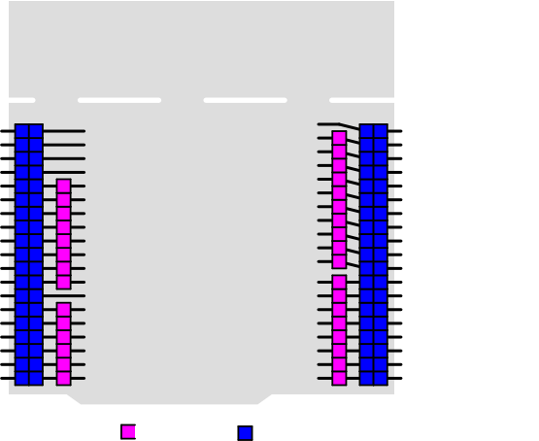
Arduino
PC10
PC12
VDD BOOT0 NC
NC
PA13
PA14
PA15
GND
PB7
PC13
PC14
PC15
PH0
PH1
VBAT
PC2
PC3
PC11
PD2
E5V
GND
NC
IOREF RESET +3V3
+5V
GND
GND
VIN
NC
PA0
PA1
PA4
PB0
PC1
PC0
PC9
PB8
PB9
AVDD
GND
PA5
PA6
PA7
PB6
PC7
PA9
PA8
PB10
PB4
PB5
PB3
PA10
PA2
PA3
PC8
PC6
PC5
U5V
NC
PA12
PA11
PB12
PB11
GND
PB2
PB1
PB15
PB14
PB13
AGND
PC4
NC
NC
D15
D14
AVDD
GND
D13
D12
D11
D10
D9
D8
D7
D6
D5
D4
D3
D2
D1
D0
NC
IOREF RESET +3V3
+5V
GND
GND
VIN
A0
A1
A2
A3
A4
A5
CN6

1
2
3
4
5
6
7
8
1
2
3
4
5
6
CN8
CN7
1 2
3 4
5 6
7 8
9 10
11 12
13 14
15 16
17 18
19 20
21 22
23 24
25 26
27 28
29 30
31 32
33 34
35 36
37 38
10
9
8
7
6
5
4
3
2
1
8
7
6
5
4
3
2
1
CN9
NUCLEO-L476RG
1
3
5
7
9
11
13
15
17
19
21
23
25
27
29
31
33
35
37
2
4
6
8
10
12
14
16
18
20
22
24
26
28
30
32
34
36
38
CN5 CN10
Morpho
MSv36556V1

Figure 24. NUCLEO.F446RE

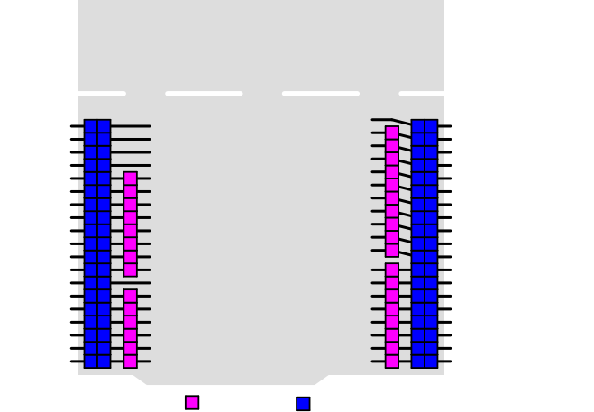  NUCLEO-F446RE  CN6  CN5 CN10  CN7  1 2  3 4  5 6  7 8  9 10  11 12  13 14  15 16  17 18  19 20  21 22  23 24  25 26  27 28  29 30  31 32  33 34  35 36  37 38  PC10  PC9  PC8  PC11  PD2  E5V  GND  NC  IOREF RESET +3V3  +5V  GND  GND  VIN  NC  PA0  PA1  PA4  PB0  PC1  PC0  1  3  5  7  9  11  13  15  17  19  21  23  25  27  29  31  33  35  37  2  4  6  8  10  12  14  16  18  20  22  24  26  28  30  32  34  36  38  D15  PB8  10  9  8  7  PC12  PC6  PB9  VDD BOOT0 NC  D14  PC5  AVDD  AVDD  U5V  GND  GND  NC  IOREF RESET +3V3  +5V  GND  GND  VIN  A0  A1  A2  A3  A4  A5  NC  1  2  3  4  5  6  7  8  D13  PA5  6  NC  PA12  PA6  PA13  5  4  3  2  D12  PA11  D11  PA7  PA14  PB12  D10  PB6  PA15  NC  D9  PC7  GND  GND  D8  PA9  1  PB7  PB2  PC13  PA8  D7  PB1  8  7  6  5  4  3  2  1  CN9  PC14  D6  PB10  PB15  PC15  D5  PB4  PB14  1  2  3  4  5  6  PH0  PB5  PB13  D4  PH1  D3  PB3  AGND  VBAT  PA10  D2  PC4  PC2  D1  NC  PA2  PC3  D0  PA3  NC  CN8  Arduino Morpho | MSv38556V1

36/91 UM1724 Rev 17

Figure 25. NUCLEO.F410RB

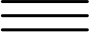
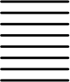
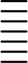
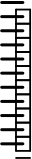
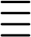
NUCLEO-F410RB
PC9 PB8 PB9 AVDD GND PA5 PA6 PA7 PB6 PC7 PA9
PA8 PB10 PB4 PB5 PB3 PA10 PA2 PA3
PC11
PB11
E5V
GND
NC
IOREF RESET +3V3
+5V GND GND VIN NC
PA0 PA1 PA4 PB0 PC1 PC0
PC8
PC6
PC5
U5V
NC
PA12 PA11
PB12 NC
GND
PB2
PB1
PB15 PB14 PB13 AGND PC4
NC NC
PC10 PC12 VDD BOOT0
NC NC PA13 PA14 PA15 GND PB7 PC13 PC14 PC15 PH0 PH1 VBAT PC2 PC3
D15 D14 AVDD GND D13 D12 D11 D10 D9 D8
D7 D6
D5 D4
D3 D2
D1 D0

1
2
3
4
5
6
7
8

NC
IOREF RESET +3V3
+5V GND GND VIN
A0 A1
A2 A3
A4 A5

1
2
3
4
5
6

CN8 CN9
CN5 CN10
9
8
7
6
5
4
3
2
1
8
7
6
5
4
3
2
1
CN7 CN6

1 | 2
3 | 4
5 | 6
7 | 8
9 | 10
11 | 12
13 | 14
15 | 16
17 | 18
19 | 20
21 | 22
23 | 24
25 | 26
27 | 28
29 | 30
31 | 32
33 | 34
35 | 36
37 | 38

1 | 2
3 | 4
5 | 6
7 | 8
9 | 10
11 | 12
13 | 14
15 | 16
17 | 18
19 | 20
21 | 22
23 | 24
25 | 26
27 | 28
29 | 30
31 | 32
33 | 34
35 | 36
37 | 38

10

口 Arduino
口 Morpho
MSv38557V1

UM1724 Rev 17 37/91

7.13 ARDUINO® connectors
CN5, CN6, CN8, and CN9 are female connectors compatible with ARDUINO® standard. Most shields designed for ARDUINO® can fit the STM32 Nucleo boards.
The ARDUINO® connectors on the STM32 Nucleo board support theARDUINO® Uno V3. For compatibility with ARDUINO® Uno V1, apply the following modifications:
• SB46 and SB52 must be ON,
• SB51 and SB56 must be OFF to connect I2C on A4 (pin 5) andA5 (pin 6 of CN8).
Caution 1: The I/Os of the STM32 microcontroller are 3.3 V compatible instead of 5 V for ARDUINO®
Uno V3.
Caution 2: SB57 must be removed before implementing the ARDUINO® shield with VREF+ power being provided on CN5 pin 8. Refer to Table 10: Solder bridges for details on SB57. Table 11 to Table 23 show the pin assignment of each main STM32 microcontroller on
ARDUINO® connectors.

Table 11. ARDUINO® connectors on NUCLEO-F030R8, NUCLEO-F070RB, NUCLEO-F072RB, NUCLEO-F091RC

Connector | Pin | Pin name | STM32 pin | Function
Left connectors
CN6 power | 1 | NC | - | -
CN6 power | 2 | IOREF | - | 3.3V Ref
CN6 power | 3 | RESET | NRST | RESET
CN6 power | 4 | +3.3V | - | 3.3V input/output
CN6 power | 5 | +5V | - | 5V output
CN6 power | 6 | GND | - | ground
CN6 power | 7 | GND | - | ground
CN6 power | 8 | VIN | - | Power input
CN8 analog | 1 | A0 | PA0 | ADC_IN0
CN8 analog | 2 | A1 | PA1 | ADC_IN1
CN8 analog | 3 | A2 | PA4 | ADC_IN4
CN8 analog | 4 | A3 | PB0 | ADC_IN8
CN8 analog | 5 | A4 | PC1 or PB9(1) | ADC_IN11 (PC1) or I2C1_SDA (PB9)
CN8 analog | 6 | A5 | PC0 or PB8(1) | ADC_IN10 (PC0) or I2C1_SCL (PB8)
Right connectors
CN5 digital | 10 | D15 | PB8 | I2C1_SCL
CN5 digital | 9 | D14 | PB9 | I2C1_SDA
CN5 digital | 8 | AREF | - | AVDD
CN5 digital | 7 | GND | - | ground

38/91 UM1724 Rev 17

Table 11. ARDUINO® connectors on NUCLEO-F030R8, NUCLEO-F070RB,
NUCLEO-F072RB, NUCLEO-F091RC (continued)

Connector | Pin | Pin name | STM32 pin | Function
CN5 digital | 6 | D13 | PA5 | SPI1_SCK
CN5 digital | 5 | D12 | PA6 | SPI1_MISO
CN5 digital | 4 | D11 | PA7 | TIM17_CH1 or SPI1_MOSI
CN5 digital | 3 | D10 | PB6 | TIM16_CH1N or SPI1_CS
CN5 digital | 2 | D9 | PC7 | TIM3_CH2
CN5 digital | 1 | D8 | PA9 | -
CN9 digital | 8 | D7 | PA8 | -
CN9 digital | 7 | D6 | PB10 | TIM2_CH3(2)
CN9 digital | 6 | D5 | PB4 | TIM3_CH1
CN9 digital | 5 | D4 | PB5 | -
CN9 digital | 4 | D3 | PB3 | TIM2_CH2(3)
CN9 digital | 3 | D2 | PA10 | -
CN9 digital | 2 | D1 | PA2 | USART2_TX
CN9 digital | 1 | D0 | PA3 | USART2_RX
1. Refer to Table 10: Solder bridges for details.
2. PWM is not supported by D6 on STM32F030 and STM32F070 since the timer is not available on PB10.
3. PWM is not supported by D3 on STM32F030 and STM32F070 since the timer is not available on PB3.

UM1724 Rev 17 39/91

Table 12. ARDUINO® connectors on NUCLEO-F103RB

Connector | Pin | Pin name | STM32 pin | Function
Left connectors
CN6 power | 1 | NC | - | -
CN6 power | 2 | IOREF | - | 3.3V Ref
CN6 power | 3 | RESET | NRST | RESET
CN6 power | 4 | +3.3V | - | 3.3V input/output
CN6 power | 5 | +5V | - | 5V output
CN6 power | 6 | GND | - | ground
CN6 power | 7 | GND | - | ground
CN6 power | 8 | VIN | - | Power input
CN8 analog | 1 | A0 | PA0 | ADC_0
CN8 analog | 2 | A1 | PA1 | ADC_1
CN8 analog | 3 | A2 | PA4 | ADC_4
CN8 analog | 4 | A3 | PB0 | ADC_8
CN8 analog | 5 | A4 | PC1 or PB9(1) | ADC_11 (PC1) or I2C1_SDA (PB9)
CN8 analog | 6 | A5 | PC0 or PB8(1) | ADC_10 (PC0) or I2C1_SCL (PB8)
Right connectors
CN5 digital | 10 | D15 | PB8 | I2C1_SCL
CN5 digital | 9 | D14 | PB9 | I2C1_SDA
CN5 digital | 8 | AREF | - | AVDD
CN5 digital | 7 | GND | - | ground
CN5 digital | 6 | D13 | PA5 | SPI1_SCK
CN5 digital | 5 | D12 | PA6 | SPI1_MISO
CN5 digital | 4 | D11 | PA7 | TIM3_CH2 or SPI1_MOSI
CN5 digital | 3 | D10 | PB6 | TIM4_CH1 or SPI1_CS
CN5 digital | 2 | D9 | PC7 | TIM3_CH2
CN5 digital | 1 | D8 | PA9 | -
CN9 digital | 8 | D7 | PA8 | -
CN9 digital | 7 | D6 | PB10 | TIM2_CH3
CN9 digital | 6 | D5 | PB4 | TIM3_CH1
CN9 digital | 5 | D4 | PB5 | -
CN9 digital | 4 | D3 | PB3 | TIM2_CH2
CN9 digital | 3 | D2 | PA10 | -
CN9 digital | 2 | D1 | PA2 | USART2_TX
CN9 digital | 1 | D0 | PA3 | USART2_RX
1. Refer to Table 10: Solder bridges for details.

40/91 UM1724 Rev 17

Table 13. ARDUINO® connectors on NUCLEO-F302R8

Connector | Pin | Pin name | STM32 pin | Function
Left connectors
CN6 power | 1 | NC | - | -
CN6 power | 2 | IOREF | - | 3.3V Ref
CN6 power | 3 | RESET | NRST | RESET
CN6 power | 4 | +3.3V | - | 3.3V input/output
CN6 power | 5 | +5V | - | 5V output
CN6 power | 6 | GND | - | ground
CN6 power | 7 | GND | - | ground
CN6 power | 8 | VIN | - | Power input
CN8 analog | 1 | A0 | PA0 | ADC_IN1
CN8 analog | 2 | A1 | PA1 | ADC_IN2
CN8 analog | 3 | A2 | PA4 | ADC_IN5
CN8 analog | 4 | A3 | PB0 | ADC_IN11
CN8 analog | 5 | A4 | PC1 or PB9(1) | ADC_IN7 (PC1) or I2C1_SDA (PB9)
CN8 analog | 6 | A5 | PC0 or PB8(1) | ADC_IN6 (PC0) or I2C1_SCL (PB8)
Right connectors
CN5 digital | 10 | D15 | PB8 | I2C1_SCL
CN5 digital | 9 | D14 | PB9 | I2C1_SDA
CN5 digital | 8 | AREF | - | AVDD
CN5 digital | 7 | GND | - | ground
CN5 digital | 6 | D13 | PB13 | SPI2_SCK
CN5 digital | 5 | D12 | PB14 | SPI2_MISO
CN5 digital | 4 | D11 | PB15 | TIM15_CH2 or SPI2_MOSI
CN5 digital | 3 | D10 | PB6 | TIM16_CH1N or SPI2_CS
CN5 digital | 2 | D9 | PC7 | -
CN5 digital | 1 | D8 | PA9 | -
CN9 digital | 8 | D7 | PA8 | -
CN9 digital | 7 | D6 | PB10 | TIM2_CH3
CN9 digital | 6 | D5 | PB4 | TIM16_CH1
CN9 digital | 5 | D4 | PB5 | -
CN9 digital | 4 | D3 | PB3 | TIM2_CH2
CN9 digital | 3 | D2 | PA10 | -
CN9 digital | 2 | D1 | PA2 | USART2_TX
CN9 digital | 1 | D0 | PA3 | USART2_RX
1. Refer to Table 10: Solder bridges for details.
UM1724 Rev 17 41/91

Warning: PWM is not supported by D9 on STM32F302 since the timer is not available on PC7.

Table 14. ARDUINO® connectors on NUCLEO-F303RE

Connector | Pin | Pin name | STM32 pin | Function
Left connectors
CN6 power | 1 | NC | - | -
CN6 power | 2 | IOREF | - | 3.3V Ref
CN6 power | 3 | RESET | NRST | RESET
CN6 power | 4 | +3.3V | - | 3.3V input/output
CN6 power | 5 | +5V | - | 5V output
CN6 power | 6 | GND | - | ground
CN6 power | 7 | GND | - | ground
CN6 power | 8 | VIN | - | Power input
CN8 analog | 1 | A0 | PA0 | ADC1_IN1
CN8 analog | 2 | A1 | PA1 | ADC1_IN2
CN8 analog | 3 | A2 | PA4 | ADC2_IN1
CN8 analog | 4 | A3 | PB0 | ADC3_IN12
CN8 analog | 5 | A4 | PC1 or PB9(1) | ADC12_IN7 (PC1) or I2C1_SDA (PB9)
CN8 analog | 6 | A5 | PC0 or PB8(1) | ADC12_IN6 (PC0) or I2C1_SCL (PB8)
Right connectors
CN5 digital | 10 | D15 | PB8 | I2C1_SCL
CN5 digital | 9 | D14 | PB9 | I2C1_SDA
CN5 digital | 8 | AREF | - | AVDD
CN5 digital | 7 | GND | - | ground
CN5 digital | 6 | D13 | PA5 | SPI1_SCK
CN5 digital | 5 | D12 | PA6 | SPI1_MISO
CN5 digital | 4 | D11 | PA7 | TIM17_CH1 or SPI1_MOSI
CN5 digital | 3 | D10 | PB6 | TIM4_CH1 or SPI1_CS
CN5 digital | 2 | D9 | PC7 | TIM3_CH2
CN5 digital | 1 | D8 | PA9 | -

42/91 UM1724 Rev 17

Table 14. ARDUINO® connectors on NUCLEO-F303RE (continued)

Connector | Pin | Pin name | STM32 pin | Function
CN9 digital | 8 | D7 | PA8 | -
CN9 digital | 7 | D6 | PB10 | TIM2_CH3
CN9 digital | 6 | D5 | PB4 | TIM3_CH1
CN9 digital | 5 | D4 | PB5 | -
CN9 digital | 4 | D3 | PB3 | TIM2_CH2
CN9 digital | 3 | D2 | PA10 | -
CN9 digital | 2 | D1 | PA2 | USART2_TX
1. Refer to Table 10: Solder bridges for details.

Table 15. ARDUINO® connectors on NUCLEO-F334R8

Connector | Pin | Pin name | STM32 pin | Function
Left connectors
CN6 power | 1 | NC | - | -
CN6 power | 2 | IOREF | - | 3.3V Ref
CN6 power | 3 | RESET | NRST | RESET
CN6 power | 4 | +3.3V | - | 3.3V input/output
CN6 power | 5 | +5V | - | 5V output
CN6 power | 6 | GND | - | ground
CN6 power | 7 | GND | - | ground
CN6 power | 8 | VIN | - | Power input
CN8 analog | 1 | A0 | PA0 | ADC1_IN1
CN8 analog | 2 | A1 | PA1 | ADC1_IN2
CN8 analog | 3 | A2 | PA4 | ADC2_IN1
CN8 analog | 4 | A3 | PB0 | ADC1_IN11
CN8 analog | 5 | A4 | PC1 or PB9(1) | ADC_IN7 (PC1) or I2C1_SDA (PB9)
CN8 analog | 6 | A5 | PC0 or PB8(1) | ADC_IN6 (PC0) or I2C1_SCL (PB8)
Right connectors
CN5 digital | 10 | D15 | PB8 | I2C1_SCL
CN5 digital | 9 | D14 | PB9 | I2C1_SDA
CN5 digital | 8 | AREF | - | AVDD
CN5 digital | 7 | GND | - | ground
CN5 digital | 6 | D13 | PA5 | SPI1_SCK
CN5 digital | 5 | D12 | PA6 | SPI1_MISO
CN5 digital | 4 | D11 | PA7 | TIM17_CH1 or SPI1_MOSI
CN5 digital | 3 | D10 | PB6 | TIM16_CH1N or SPI1_CS

UM1724 Rev 17 43/91

Table 15. ARDUINO® connectors on NUCLEO-F334R8 (continued)

Connector | Pin | Pin name | STM32 pin | Function
CN5 digital | 2 | D9 | PC7 | TIM3_CH2
CN5 digital | 1 | D8 | PA9 | -
CN9 digital | 8 | D7 | PA8 | -
CN9 digital | 7 | D6 | PB10 | TIM2_CH3
CN9 digital | 6 | D5 | PB4 | TIM3_CH1
CN9 digital | 5 | D4 | PB5 | -
CN9 digital | 4 | D3 | PB3 | TIM2_CH2
CN9 digital | 3 | D2 | PA10 | -
CN9 digital | 2 | D1 | PA2 | USART2_TX
CN9 digital | 1 | D0 | PA3 | USART2_RX
1. Refer to Table 10: Solder bridges for details.

Table 16. ARDUINO® connectors on NUCLEO-F401RE and NUCLEO-F411RE

Connector | Pin | Pin name | STM32 pin | Function
Left connectors
CN6 power | 1 | NC | - | -
CN6 power | 2 | IOREF | - | 3.3V Ref
CN6 power | 3 | RESET | NRST | RESET
CN6 power | 4 | +3.3V | - | 3.3V input/output
CN6 power | 5 | +5V | - | 5V output
CN6 power | 6 | GND | - | ground
CN6 power | 7 | GND | - | ground
CN6 power | 8 | VIN | - | Power input
CN8 analog | 1 | A0 | PA0 | ADC1_0
CN8 analog | 2 | A1 | PA1 | ADC1_1
CN8 analog | 3 | A2 | PA4 | ADC1_4
CN8 analog | 4 | A3 | PB0 | ADC1_8
CN8 analog | 5 | A4 | PC1 or PB9(1) | ADC1_11 (PC1) or I2C1_SDA (PB9)
CN8 analog | 6 | A5 | PC0 or PB8(1) | ADC1_10 (PC0) or I2C1_SCL (PB8)
Right connectors
CN5 digital | 10 | D15 | PB8 | I2C1_SCL
CN5 digital | 9 | D14 | PB9 | I2C1_SDA
CN5 digital | 8 | AREF | - | AVDD
CN5 digital | 7 | GND | - | ground

44/91 UM1724 Rev 17

Table 16. ARDUINO® connectors on NUCLEO-F401RE and NUCLEO-F411RE (continued)

Connector | Pin | Pin name | STM32 pin | Function
CN5 digital | 6 | D13 | PA5 | SPI1_SCK
CN5 digital | 5 | D12 | PA6 | SPI1_MISO
CN5 digital | 4 | D11 | PA7 | TIM1_CH1N or SPI1_MOSI
CN5 digital | 3 | D10 | PB6 | TIM4_CH1 or SPI1_CS
CN5 digital | 2 | D9 | PC7 | TIM3_CH2
CN5 digital | 1 | D8 | PA9 | -
CN9 digital | 8 | D7 | PA8 | -
CN9 digital | 7 | D6 | PB10 | TIM2_CH3
CN9 digital | 6 | D5 | PB4 | TIM3_CH1
CN9 digital | 5 | D4 | PB5 | -
CN9 digital | 4 | D3 | PB3 | TIM2_CH2
CN9 digital | 3 | D2 | PA10 | -
CN9 digital | 2 | D1 | PA2 | USART2_TX
CN9 digital | 1 | D0 | PA3 | USART2_RX
1. Refer to Table 10: Solder bridges for details.

UM1724 Rev 17 45/91

Table 17. ARDUINO® connectors on NUCLEO-L053R8

Connector | Pin | Pin name | STM32 pin | Function
Left connectors
CN6 power | 1 | NC | - | -
CN6 power | 2 | IOREF | - | 3.3V Ref
CN6 power | 3 | RESET | NRST | RESET
CN6 power | 4 | +3.3V | - | 3.3V input/output
CN6 power | 5 | +5V | - | 5V output
CN6 power | 6 | GND | - | ground
CN6 power | 7 | GND | - | ground
CN6 power | 8 | VIN | - | Power input
CN8 analog | 1 | A0 | PA0 | ADC_IN0
CN8 analog | 2 | A1 | PA1 | ADC_IN1
CN8 analog | 3 | A2 | PA4 | ADC_IN4
CN8 analog | 4 | A3 | PB0 | ADC_IN8
CN8 analog | 5 | A4 | PC1 or PB9(1) | ADC_IN11 (PC1) or I2C1_SDA (PB9)
CN8 analog | 6 | A5 | PC0 or PB8(1) | ADC_IN10 (PC0) or I2C1_SCL (PB8)
Right connectors
CN5 digital | 10 | D15 | PB8 | I2C1_SCL
CN5 digital | 9 | D14 | PB9 | I2C1_SDA
CN5 digital | 8 | AREF | - | AVDD
CN5 digital | 7 | GND | - | ground
CN5 digital | 6 | D13 | PA5 | SPI1_SCK
CN5 digital | 5 | D12 | PA6 | SPI1_MISO
CN5 digital | 4 | D11 | PA7 | TIM12_CH2 or SPI1_MOSI
CN5 digital | 3 | D10 | PB6 | SPI1_CS
CN5 digital | 2 | D9 | PC7 | TIM12_CH2
CN5 digital | 1 | D8 | PA9 | -
CN9 digital | 8 | D7 | PA8 | -
CN9 digital | 7 | D6 | PB10 | TIM2_CH3
CN9 digital | 6 | D5 | PB4 | TIM12_CH1
CN9 digital | 5 | D4 | PB5 | -
CN9 digital | 4 | D3 | PB3 | TIM2_CH2
CN9 digital | 3 | D2 | PA10 | -
CN9 digital | 2 | D1 | PA2 | USART2_TX
CN9 digital | 1 | D0 | PA3 | USART2_RX
1. Refer to Table 10: Solder bridges for details.
46/91 UM1724 Rev 17

Warning: PWM is not supported by D10 on STM32L053 since the timer is not available on PB6.

Table 18. ARDUINO® connectors on NUCLEO-L010RB and NUCLEO-L073RZ

Connector | Pin | Pin name | STM32 pin | Function
Left connectors
CN6 power | 1 | NC | - | -
CN6 power | 2 | IOREF | - | 3.3V Ref
CN6 power | 3 | RESET | NRST | RESET
CN6 power | 4 | +3.3V | - | 3.3V input/output
CN6 power | 5 | +5V | - | 5V output
CN6 power | 6 | GND | - | ground
CN6 power | 7 | GND | - | ground
CN6 power | 8 | VIN | - | Power input
CN8  analog | 1 | A0 | PA0 | ADC_IN0
CN8  analog | 2 | A1 | PA1 | ADC_IN1
CN8  analog | 3 | A2 | PA4 | ADC_IN4
CN8  analog | 4 | A3 | PB0 | ADC_IN8
CN8  analog | 5 | A4 | PC1 or PB9(1) | ADC_IN11 (PC1) or I2C1_SDA (PB9)
CN8  analog | 6 | A5 | PC0 or PB8(1) | ADC_IN10 (PC0) or I2C1_SCL (PB8)
Right connectors
CN5 digital | 10 | D15 | PB8 | I2C1_SCL
CN5 digital | 9 | D14 | PB9 | I2C1_SDA
CN5 digital | 8 | AREF | - | AVDD
CN5 digital | 7 | GND | - | ground
CN5 digital | 6 | D13 | PA5 | SPI1_SCK
CN5 digital | 5 | D12 | PA6 | SPI1_MISO
CN5 digital | 4 | D11 | PA7 | TIM22_CH2 or SPI1_MOSI
CN5 digital | 3 | D10 | PB6 | SPI1_CS
CN5 digital | 2 | D9 | PC7 | TIM3_CH2
CN5 digital | 1 | D8 | PA9 | -

UM1724 Rev 17 47/91

Table 18. ARDUINO® connectors on NUCLEO-L010RB and NUCLEO-L073RZ (continued)

Connector | Pin | Pin name | STM32 pin | Function
CN9 digital | 8 | D7 | PA8 | -
CN9 digital | 7 | D6 | PB10 | TIM2_CH3
CN9 digital | 6 | D5 | PB4 | TIM3_CH1
CN9 digital | 5 | D4 | PB5 | -
CN9 digital | 4 | D3 | PB3 | TIM2_CH2
CN9 digital | 3 | D2 | PA10 | -
CN9 digital | 2 | D1 | PA2 | USART2_TX
CN9 digital | 1 | D0 | PA3 | USART2_RX
1. Refer to Table 10: Solder bridges for details.

Warning: PWM is not supported by D10 on STM32L010 and STM32L073 since the timer is not available on PB6.

Table 19. ARDUINO® connectors on NUCLEO-F446RE

Connector | Pin | Pin name | STM32 pin | Function
Left connectors
CN6 power | 1 | NC | - | -
CN6 power | 2 | IOREF | - | 3.3V Ref
CN6 power | 3 | RESET | NRST | RESET
CN6 power | 4 | +3.3V | - | 3.3V input/output
CN6 power | 5 | +5V | - | 5V output
CN6 power | 6 | GND | - | ground
CN6 power | 7 | GND | - | ground
CN6 power | 8 | VIN | - | Power input
CN8  analog | 1 | A0 | PA0 | ADC123_IN0
CN8  analog | 2 | A1 | PA1 | ADC123_IN1
CN8  analog | 3 | A2 | PA4 | ADC12_IN4
CN8  analog | 4 | A3 | PB0 | ADC12_IN8
CN8  analog | 5 | A4 | PC1 or PB9(1) | ADC123_IN11 (PC1) or I2C1_SDA (PB9)
CN8  analog | 6 | A5 | PC0 or PB8(1) | ADC123_IN10 (PC0) or I2C1_SCL (PB8)
Right connectors
CN5 digital | 10 | D15 | PB8 | I2C1_SCL
CN5 digital | 9 | D14 | PB9 | I2C1_SDA

48/91 UM1724 Rev 17

Table 19. ARDUINO® connectors on NUCLEO-F446RE (continued)

Connector | Pin | Pin name | STM32 pin | Function
CN5 digital | 8 | AREF | - | AVDD
CN5 digital | 7 | GND | - | ground
CN5 digital | 6 | D13 | PA5 | SPI1_SCK
CN5 digital | 5 | D12 | PA6 | SPI1_MISO
CN5 digital | 4 | D11 | PA7 | TIM14_CH1 || SPI1_MOSI
CN5 digital | 3 | D10 | PB6 | TIM4_CH1 || SPI1_CS
CN5 digital | 2 | D9 | PC7 | TIM8_CH2
CN5 digital | 1 | D8 | PA9 | -
CN9 digital | 8 | D7 | PA8 | -
CN9 digital | 7 | D6 | PB10 | TIM2_CH3
CN9 digital | 6 | D5 | PB4 | TIM3_CH1
CN9 digital | 5 | D4 | PB5 | -
CN9 digital | 4 | D3 | PB3 | TIM2_CH2
CN9 digital | 3 | D2 | PA10 | -
CN9 digital | 2 | D1 | PA2 | USART2_TX
CN9 digital | 1 | D0 | PA3 | USART2_RX
1. Refer to Table 10: Solder bridges for details.

UM1724 Rev 17 49/91

Table 20. ARDUINO® connectors on NUCLEO-F410RB

Connector | Pin | Pin name | STM32 pin | Function
Left connectors
CN6 power | 1 | NC | - | -
CN6 power | 2 | IOREF | - | 3.3V Ref
CN6 power | 3 | RESET | NRST | RESET
CN6 power | 4 | +3.3V | - | 3.3V input/output
CN6 power | 5 | +5V | - | 5V output
CN6 power | 6 | GND | - | ground
CN6 power | 7 | GND | - | ground
CN6 power | 8 | VIN | - | Power input
CN8  analog | 1 | A0 | PA0 | ADC1_0
CN8  analog | 2 | A1 | PA1 | ADC1_1
CN8  analog | 3 | A2 | PA4 | ADC1_4
CN8  analog | 4 | A3 | PB0 | ADC1_8
CN8  analog | 5 | A4 | PC1 or PB9(1) | ADC1_11 (PC1) or I2C1_SDA (PB9)
CN8  analog | 6 | A5 | PC0 or PB8(1) | ADC1_10 (PC0) or I2C1_SCL (PB8)
Right connectors
CN5 digital | 10 | PB8 | D15 | I2C1_SCL
CN5 digital | 9 | PB9 | D14 | I2C1_SDA
CN5 digital | 8 | - | AREF | AVDD
CN5 digital | 7 | - | GND | ground
CN5 digital | 6 | PA5 | D13 | SPI1_SCK
CN5 digital | 5 | PA6 | D12 | SPI1_MISO
CN5 digital | 4 | PA7 | D11 | TIM1_CH1N || SPI1_MOSI
CN5 digital | 3 | PB6 | D10 | SPI1_CS
CN5 digital | 2 | PC7 | D9 | -
CN5 digital | 1 | PA9 | D8 | -
CN9 digital | 8 | PA8 | D7 | -
CN9 digital | 7 | PB10 | D6 | -
CN9 digital | 6 | PB4 | D5 | -
CN9 digital | 5 | PB5 | D4 | -
CN9 digital | 4 | PB3 | D3 | -
CN9 digital | 3 | PA10 | D2 | -
CN9 digital | 2 | PA2 | D1 | USART2_TX
CN9 digital | 1 | PA3 | D0 | USART2_RX
1. Refer to Table 10: Solder bridges for details.
50/91 UM1724 Rev 17

Warning: PWM is not supported by D3, D5, D6, D9 and D10 on STM32F410RB
since timer is not available on PB6, PC7, PB10, PB4, PB3.

Table 21. ARDUINO® connectors on NUCLEO-L152RE

Connector | Pin | Pin name | STM32 pin | Function
Left connectors
CN6 power | 1 | NC | - | -
CN6 power | 2 | IOREF | - | 3.3V Ref
CN6 power | 3 | RESET | NRST | RESET
CN6 power | 4 | +3.3V | - | 3.3V input/output
CN6 power | 5 | +5V | - | 5V output
CN6 power | 6 | GND | - | ground
CN6 power | 7 | GND | - | ground
CN6 power | 8 | VIN | - | Power input
CN8 analog | 1 | A0 | PA0 | ADC_IN0
CN8 analog | 2 | A1 | PA1 | ADC_IN1
CN8 analog | 3 | A2 | PA4 | ADC_IN4
CN8 analog | 4 | A3 | PB0 | ADC_IN8
CN8 analog | 5 | A4 | PC1 or PB9(1) | ADC_IN11 (PC1) or I2C1_SDA (PB9)
CN8 analog | 6 | A5 | PC0 or PB8(1) | ADC_IN10 (PC0) or I2C1_SCL (PB8)
Right connectors
CN5 digital | 10 | D15 | PB8 | I2C1_SCL
CN5 digital | 9 | D14 | PB9 | I2C1_SDA
CN5 digital | 8 | AREF | - | AVDD
CN5 digital | 7 | GND | - | ground
CN5 digital | 6 | D13 | PA5 | SPI1_SCK
CN5 digital | 5 | D12 | PA6 | SPI1_MISO
CN5 digital | 4 | D11 | PA7 | TIM11_CH1 or SPI1_MOSI
CN5 digital | 3 | D10 | PB6 | TIM4_CH1 or SPI1_CS
CN5 digital | 2 | D9 | PC7 | TIM3_CH2
CN5 digital | 1 | D8 | PA9 | -
CN9 digital | 8 | D7 | PA8 | -
CN9 digital | 7 | D6 | PB10 | TIM2_CH3
CN9 digital | 6 | D5 | PB4 | TIM3_CH1
CN9 digital | 5 | D4 | PB5 | -

UM1724 Rev 17 51/91

Table 21. ARDUINO® connectors on NUCLEO-L152RE (continued)

Connector | Pin | Pin name | STM32 pin | Function
CN9 digital | 4 | D3 | PB3 | TIM2_CH2
CN9 digital | 3 | D2 | PA10 | -
CN9 digital | 2 | D1 | PA2 | USART2_TX
CN9 digital | 1 | D0 | PA3 | USART2_RX
1. Refer to Table 10: Solder bridges for details.

Table 22. ARDUINO® connectors on NUCLEO-L452RE

Connector | Pin | Pin name | STM32 pin | Function
Left connectors
CN6 power | 1 | NC | - | -
CN6 power | 2 | IOREF | - | 3.3V Ref
CN6 power | 3 | RESET | NRST | RESET
CN6 power | 4 | +3.3V | - | 3.3V input/output
CN6 power | 5 | +5V | - | 5V output
CN6 power | 6 | GND | - | ground
CN6 power | 7 | GND | - | ground
CN6 power | 8 | VIN | - | Power input
CN8  analog | 1 | A0 | PA0 | ADC1_IN5
CN8  analog | 2 | A1 | PA1 | ADC1_IN6
CN8  analog | 3 | A2 | PA4 | ADC1_IN9
CN8  analog | 4 | A3 | PB0 | ADC1_IN15
CN8  analog | 5 | A4 | PC1 or PB9(1) | ADC1_IN2 (PC1) or I2C1_SDA (PB9)
CN8  analog | 6 | A5 | PC0 or PB8(1) | ADC1_IN1 (PC0) or I2C1_SCL (PB8)
Right connectors
CN5 digital | 10 | D15 | PB8 | I2C1_SCL
CN5 digital | 9 | D14 | PB9 | I2C1_SDA
CN5 digital | 8 | AREF | - | AVDD
CN5 digital | 7 | GND | - | ground
CN5 digital | 6 | D13 | PA5 | SPI1_SCK
CN5 digital | 5 | D12 | PA6 | SPI1_MISO
CN5 digital | 4 | D11 | PA7 | TIM1_CH1N or SPI1_MOSI
CN5 digital | 3 | D10 | PB6 | TIM16_CH1N or SPI1_CS
CN5 digital | 2 | D9 | PC7 | TIM3_CH2
CN5 digital | 1 | D8 | PA9 | -
CN9 digital | 8 | D7 | PA8 | -

52/91 UM1724 Rev 17

Table 22. ARDUINO® connectors on NUCLEO-L452RE (continued)

Connector | Pin | Pin name | STM32 pin | Function
CN9 digital | 7 | D6 | PB10 | TIM2_CH3
CN9 digital | 6 | D5 | PB4 | TIM3_CH1
CN9 digital | 5 | D4 | PB5 | -
CN9 digital | 4 | D3 | PB3 | TIM2_CH2
CN9 digital | 3 | D2 | PA10 | -
CN9 digital | 2 | D1 | PA2 | USART2_TX
CN9 digital | 1 | D0 | PA3 | USART2_RX
1. Refer to Table 10: Solder bridges for details.

Table 23. ARDUINO® connectors on NUCLEO-L476RG

Connector | Pin | Pin name | STM32 pin | Function
Left connectors
CN6 power | 1 | NC | - | -
CN6 power | 2 | IOREF | - | 3.3V Ref
CN6 power | 3 | RESET | NRST | RESET
CN6 power | 4 | +3.3V | - | 3.3V input/output
CN6 power | 5 | +5V | - | 5V output
CN6 power | 6 | GND | - | ground
CN6 power | 7 | GND | - | ground
CN6 power | 8 | VIN | - | Power input
CN8  analog | 1 | A0 | PA0 | ADC12_IN5
CN8  analog | 2 | A1 | PA1 | ADC12_IN6
CN8  analog | 3 | A2 | PA4 | ADC12_IN9
CN8  analog | 4 | A3 | PB0 | ADC12_IN15
CN8  analog | 5 | A4 | PC1 or PB9(1) | ADC123_IN2 (PC1) or I2C1_SDA (PB9)
CN8  analog | 6 | A5 | PC0 or PB8(1) | ADC123_IN1 (PC0) or I2C1_SCL (PB8)
Right connectors
CN5 digital | 10 | D15 | PB8 | I2C1_SCL
CN5 digital | 9 | D14 | PB9 | I2C1_SDA
CN5 digital | 8 | AREF | - | AVDD
CN5 digital | 7 | GND | - | ground
CN5 digital | 6 | D13 | PA5 | SPI1_SCK
CN5 digital | 5 | D12 | PA6 | SPI1_MISO
CN5 digital | 4 | D11 | PA7 | TIM17_CH1 or SPI1_MOSI
CN5 digital | 3 | D10 | PB6 | TIM4_CH1 or SPI1_CS

UM1724 Rev 17 53/91

Table 23. ARDUINO® connectors on NUCLEO-L476RG (continued)

Connector | Pin | Pin name | STM32 pin | Function
CN5 digital | 2 | D9 | PC7 | TIM3_CH2
CN5 digital | 1 | D8 | PA9 | -
CN9 digital | 8 | D7 | PA8 | -
CN9 digital | 7 | D6 | PB10 | TIM2_CH3
CN9 digital | 6 | D5 | PB4 | TIM3_CH1
CN9 digital | 5 | D4 | PB5 | -
CN9 digital | 4 | D3 | PB3 | TIM2_CH2
CN9 digital | 3 | D2 | PA10 | -
CN9 digital | 2 | D1 | PA2 | USART2_TX
CN9 digital | 1 | D0 | PA3 | USART2_RX
1. Refer to Table 10: Solder bridges for details.

7.14 ST morpho connector
The ST morpho connector consists of male pin headers (CN7 and CN10) accessible on
both sides of the board. They can be used to connect the STM32 Nucleo board to an
extension board or a prototype/wrapping board placed on the top or bottom side of the
STM32 Nucleo board. All signals and power pins of the STM32 are available on the ST
morpho connector. This connector can also be probed by an oscilloscope, logical analyzer, or voltmeter.
Table 24 to Table 33 show the pin assignments of each STM32 on the ST morpho connector.

Table 24. ST morpho connector on NUCLEO-F030R8

CN7 odd pins |  | CN7 even pins |  | CN10 odd pins |  | CN10 even pins
Pin | Name | Name | Pin | Pin | Name | Name | Pin
1 | PC10 | PC11 | 2 | 1 | PC9 | PC8 | 2
3 | PC12 | PD2 | 4 | 3 | PB8 | PC6 | 4
5 | VDD | E5V | 6 | 5 | PB9 | PC5 | 6
7 | BOOT0(1) | GND | 8 | 7 | AVDD | U5V(2) | 8
9 | PF6 | - | 10 | 9 | GND | - | 10
11 | PF7 | IOREF | 12 | 11 | PA5 | PA12 | 12
13 | PA13 | RESET | 14 | 13 | PA6 | PA11 | 14
15 | PA14 | +3.3V | 16 | 15 | PA7 | PB12 | 16
17 | PA15 | +5V | 18 | 17 | PB6 | PB11 | 18
19 | GND | GND | 20 | 19 | PC7 | GND | 20
21 | PB7 | GND | 22 | 21 | PA9 | PB2 | 22

54/91 UM1724 Rev 17

Table 24. ST morpho connector on NUCLEO-F030R8 (continued)

CN7 odd pins |  | CN7 even pins |  | CN10 odd pins |  | CN10 even pins
Pin | Name | Name | Pin | Pin | Name | Name | Pin
23 | PC13(3) | VIN | 24 | 23 | PA8 | PB1 | 24
25 | PC14(3) | - | 26 | 25 | PB10 | PB15 | 26
27 | PC15 | PA0 | 28 | 27 | PB4 | PB14 | 28
29 | PF0 | PA1 | 30 | 29 | PB5 | PB13 | 30
31 | PF1 | PA4 | 32 | 31 | PB3 | AGND | 32
33 | VBAT | PB0 | 34 | 33 | PA10 | PC4 | 34
35 | PC2 | PC1 or  PB9(4) | 36 | 35 | PA2 | PF5 | 36
37 | PC3 | PC0 or  PB8(4) | 38 | 37 | PA3 | PF4 | 38
1. The default state of BOOT0 is LOW. It can be set to HIGH when a jumper is on pin5-7 of CN7. Two unused jumpers are available on CN11 and CN12 (bottom side of the board).
2. U5V is 5 V power from ST-LINK/V2-1 USB connector and it rises before +5V.
3. PA13 and PA14 share with SWD signals connected to ST-LINK/V2-1, it is not recommended to use them as IO pins if the ST-LINK part is not cut.
4. Refer to Table 10: Solder bridges for details.

connector on NUCLEO-F070RB
Table 25. ST
morpho

CN7 odd pins |  | CN7 even pins |  | CN10 odd pins |  | CN10 even pins
Pin | Name | Name | Pin | Pin | Name | Name | Pin
1 | PC10 | PC11 | 2 | 1 | PC9 | PC8 | 2
3 | PC12 | PD2 | 4 | 3 | PB8 | PC6 | 4
5 | VDD | E5V | 6 | 5 | PB9 | PC5 | 6
7 | BOOT0(1) | GND | 8 | 7 | AVDD | U5V(2) | 8
9 | - | - | 10 | 9 | GND | - | 10
11 | - | IOREF | 12 | 11 | PA5 | PA12 | 12
13 | PA13(3) | RESET | 14 | 13 | PA6 | PA11 | 14
15 | PA14(3) | +3.3V | 16 | 15 | PA7 | PB12 | 16
17 | PA15 | +5V | 18 | 17 | PB6 | PB11 | 18
19 | GND | GND | 20 | 19 | PC7 | GND | 20
21 | PB7 | GND | 22 | 21 | PA9 | PB2 | 22
23 | PC13 | VIN | 24 | 23 | PA8 | PB1 | 24
25 | PC14 | - | 26 | 25 | PB10 | PB15 | 26
27 | PC15 | PA0 | 28 | 27 | PB4 | PB14 | 28
29 | PF0 | PA1 | 30 | 29 | PB5 | PB13 | 30
31 | PF1 | PA4 | 32 | 31 | PB3 | AGND | 32
33 | VDD | PB0 | 34 | 33 | PA10 | PC4 | 34
35 | PC2 | PC1 or PB9(4) | 36 | 35 | PA2 | - | 36
37 | PC3 | PC0 or PB8(4) | 38 | 37 | PA3 | - | 38
1. The default state of BOOT0 is LOW. It can be set to HIGH when a jumper is on pin5-7 of CN7.
2. U5V is 5 V power from ST-LINK/V2-1 USB connector and it rises before +5V.

UM1724 Rev 17 55/91

3. PA13 and PA14 share with SWD signals connected to ST-LINK/V2-1, it is not recommended to use them
as IO pins if the ST-LINK part is not cut.
4. Refer to Table 10: Solder bridges for details.

Table 26. ST morpho connector on

NUCLEO-F072RB, NUCLEO-F091RC, NUCLEO-F303RE, NUCLEO-F334R8

CN7 odd pins |  | CN7 even pins |  | CN10 odd pins |  | CN10 even pins
Pin | Name | Name | Pin | Pin | Name | Name | Pin
1 | PC10 | PC11 | 2 | 1 | PC9 | PC8 | 2
3 | PC12 | PD2 | 4 | 3 | PB8 | PC6 | 4
5 | VDD | E5V | 6 | 5 | PB9 | PC5 | 6
7 | BOOT0(1)(2) | GND | 8 | 7 | AVDD | U5V(3) | 8
9 | - | - | 10 | 9 | GND | - | 10
11 | - | IOREF | 12 | 11 | PA5 | PA12 | 12
13 | PA13(4) | RESET | 14 | 13 | PA6 | PA11 | 14
15 | PA14(4) | +3.3V | 16 | 15 | PA7 | PB12 | 16
17 | PA15 | +5V | 18 | 17 | PB6 | PB11 | 18
19 | GND | GND | 20 | 19 | PC7 | GND | 20
21 | PB7 | GND | 22 | 21 | PA9 | PB2 | 22
23 | PC13 | VIN | 24 | 23 | PA8 | PB1 | 24
25 | PC14 | - | 26 | 25 | PB10 | PB15 | 26
27 | PC15 | PA0 | 28 | 27 | PB4 | PB14 | 28
29 | PF0 | PA1 | 30 | 29 | PB5 | PB13 | 30
31 | PF1 | PA4 | 32 | 31 | PB3 | AGND | 32
33 | VBAT | PB0 | 34 | 33 | PA10 | PC4 | 34
35 | PC2 | PC1 or  PB9(5) | 36 | 35 | PA2 | - | 36
37 | PC3 | PC0 or  PB8(5) | 38 | 37 | PA3 | - | 38
1. The default state of BOOT0 is LOW. It can be set to HIGH when a jumper is on pin5-7 of CN7. Two unused jumpers are available on CN11 and CN12 (bottom side of the board).
2. CN7 pin 7 (BOOT0) can be configured by engineering byte as PF11 on NUCLEO-F091RC.
3. U5V is 5 V power from ST-LINK/V2-1 USB connector and it rises before +5V.
4. PA13 and PA14 share with SWD signals connected to ST-LINK/V2-1, it is not recommended to use them as IO pins if the ST-LINK part is not cut.
5. Refer to Table 10: Solder bridges for details.

56/91 UM1724 Rev 17

Table 27. ST morpho connector on NUCLEO.F103RB

CN7 odd pins |  | CN7 even pins |  | CN10 odd pins |  | CN10 even pins
Pin | Name | Name | Pin | Pin | Name | Name | Pin
1 | PC10 | PC11 | 2 | 1 | PC9 | PC8 | 2
3 | PC12 | PD2 | 4 | 3 | PB8 | PC6 | 4
5 | VDD | E5V | 6 | 5 | PB9 | PC5 | 6
7 | BOOT0(1) | GND | 8 | 7 | AVDD | U5V(2) | 8
9 | - | - | 10 | 9 | GND | - | 10
11 | - | IOREF | 12 | 11 | PA5 | PA12 | 12
13 | PA13(3) | RESET | 14 | 13 | PA6 | PA11 | 14
15 | PA14(3) | +3.3V | 16 | 15 | PA7 | PB12 | 16
17 | PA15 | +5V | 18 | 17 | PB6 | PB11 | 18
19 | GND | GND | 20 | 19 | PC7 | GND | 20
21 | PB7 | GND | 22 | 21 | PA9 | PB2 | 22
23 | PC13 | VIN | 24 | 23 | PA8 | PB1 | 24
25 | PC14 | - | 26 | 25 | PB10 | PB15 | 26
27 | PC15 | PA0 | 28 | 27 | PB4 | PB14 | 28
29 | PD0 | PA1 | 30 | 29 | PB5 | PB13 | 30
31 | PD1 | PA4 | 32 | 31 | PB3 | AGND | 32
33 | VBAT | PB0 | 34 | 33 | PA10 | PC4 | 34
35 | PC2 | PC1 or  PB9(4) | 36 | 35 | PA2 | - | 36
37 | PC3 | PC0 or  PB8(4) | 38 | 37 | PA3 | - | 38
1. The default state of BOOT0 is LOW. It can be set to HIGH when a jumper is on pin5-7 of CN7. Two unused jumpers are available on CN11 and CN12 (bottom side of the board).
2. U5V is 5 V power from ST-LINK/V2-1 USB connector and it rises before +5 V.
3. PA13 and PA14 share with SWD signals connected to ST-LINK/V2-1, it is not recommended to use them as IO pins if the ST-LINK part is not cut.
4. Refer to Table 10: Solder bridges for details.

UM1724 Rev 17 57/91

Table 28. ST morpho connector on NUCLEO.F302R8

CN7 odd pins |  | CN7 even pins |  | CN10 odd pins |  | CN10 even pins
Pin | Name | Name | Pin | Pin | Name | Name | Pin
1 | PC10 | PC11 | 2 | 1 | PC9 | PC8 | 2
3 | PC12 | PD2 | 4 | 3 | PB8 | PC6 | 4
5 | VDD | E5V | 6 | 5 | PB9 | PC5 | 6
7 | BOOT0(1) | GND | 8 | 7 | AVDD | U5V(2) | 8
9 | - | - | 10 | 9 | GND | - | 10
11 | - | IOREF | 12 | 11 | PB13 | PA12 | 12
13 | PA13(3) | RESET | 14 | 13 | PB14 | PA11 | 14
15 | PA14(3) | +3.3V | 16 | 15 | PB15 | PB12 | 16
17 | PA15 | +5V | 18 | 17 | PB6 | PB11 | 18
19 | GND | GND | 20 | 19 | PC7 | GND | 20
21 | PB7 | GND | 22 | 21 | PA9 | PB2 | 22
23 | PC13 | VIN | 24 | 23 | PA8 | PB1 | 24
25 | PC14 | - | 26 | 25 | PB10 | PA7 | 26
27 | PC15 | PA0 | 28 | 27 | PB4 | PA6 | 28
29 | PF0 | PA1 | 30 | 29 | PB5 | PA5 | 30
31 | PF1 | PA4 | 32 | 31 | PB3 | AGND | 32
33 | VBAT | PB0 | 34 | 33 | PA10 | PC4 | 34
35 | PC2 | PC1 or  PB9(4) | 36 | 35 | PA2 | - | 36
37 | PC3 | PC0 or  PB8(4) | 38 | 37 | PA3 | - | 38
1. The default state of BOOT0 is LOW. It can be set to HIGH when a jumper is on pin5-7 of CN7. Two unused jumpers are available on CN11 and CN12 (bottom side of the board).
2. U5V is 5 V power from ST-LINK/V2-1 USB connector and it rises before +5V.
3. PA13 and PA14 share with SWD signals connected to ST-LINK/V2-1, it is not recommended to use them as IO pins if the ST-LINK part is not cut.
4. Refer to Table 10: Solder bridges for details.

58/91 UM1724 Rev 17

Table 29. ST morpho connector on NUCLEO-F401RE, NUCLEO-F411RE, NUCLEO-F446RE

CN7 odd pins |  | CN7 even pins |  | CN10 odd pins |  | CN10 even pins
Pin | Name | Name | Pin | Pin | Name | Name | Pin
1 | PC10 | PC11 | 2 | 1 | PC9 | PC8 | 2
3 | PC12 | PD2 | 4 | 3 | PB8 | PC6 | 4
5 | VDD | E5V | 6 | 5 | PB9 | PC5 | 6
7 | BOOT0(1) | GND | 8 | 7 | AVDD | U5V(2) | 8
9 | - | - | 10 | 9 | GND | - | 10
11 | - | IOREF | 12 | 11 | PA5 | PA12 | 12
13 | PA13(3) | RESET | 14 | 13 | PA6 | PA11 | 14
15 | PA14(3) | +3.3V | 16 | 15 | PA7 | PB12 | 16
17 | PA15 | +5V | 18 | 17 | PB6 | - | 18
19 | GND | GND | 20 | 19 | PC7 | GND | 20
21 | PB7 | GND | 22 | 21 | PA9 | PB2 | 22
23 | PC13 | VIN | 24 | 23 | PA8 | PB1 | 24
25 | PC14 | - | 26 | 25 | PB10 | PB15 | 26
27 | PC15 | PA0 | 28 | 27 | PB4 | PB14 | 28
29 | PH0 | PA1 | 30 | 29 | PB5 | PB13 | 30
31 | PH1 | PA4 | 32 | 31 | PB3 | AGND | 32
33 | VBAT | PB0 | 34 | 33 | PA10 | PC4 | 34
35 | PC2 | PC1 or  PB9(4) | 36 | 35 | PA2 | - | 36
37 | PC3 | PC0 or  PB8(4) | 38 | 37 | PA3 | - | 38
1. The default state of BOOT0 is LOW. It can be set to HIGH when a jumper is on pin5-7 of CN7. Two unused jumpers are available on CN11 and CN12 (bottom side of the board).
2. U5V is 5 V power from ST-LINK/V2-1 USB connector and it rises before +5V.
3. PA13 and PA14 share with SWD signals connected to ST-LINK/V2-1, it is not recommended to use them as IO pins if the ST-LINK part is not cut.
4. Refer to Table 10: Solder bridges for details.

UM1724 Rev 17 59/91

Table 30. ST morpho connector on NUCLEO-L010RB, NUCLEO-L053R8, NUCLEO-L073RZ, NUCLEO-L152RE

CN7 odd pins |  | CN7 even pins |  | CN10 odd pins |  | CN10 even pins
Pin | Name | Name | Pin | Pin | Name | Name | Pin
1 | PC10 | PC11 | 2 | 1 | PC9 | PC8 | 2
3 | PC12 | PD2 | 4 | 3 | PB8 | PC6 | 4
5 | VDD | E5V | 6 | 5 | PB9 | PC5 | 6
7 | BOOT0(1) | GND | 8 | 7 | AVDD | U5V(2) | 8
9 | - | - | 10 | 9 | GND | - | 10
11 | - | IOREF | 12 | 11 | PA5 | PA12 | 12
13 | PA13(3) | RESET | 14 | 13 | PA6 | PA11 | 14
15 | PA14(3) | +3.3V | 16 | 15 | PA7 | PB12 | 16
17 | PA15 | +5V | 18 | 17 | PB6 | PB11 | 18
19 | GND | GND | 20 | 19 | PC7 | GND | 20
21 | PB7 | GND | 22 | 21 | PA9 | PB2 | 22
23 | PC13 | VIN | 24 | 23 | PA8 | PB1 | 24
25 | PC14 | - | 26 | 25 | PB10 | PB15 | 26
27 | PC15 | PA0 | 28 | 27 | PB4 | PB14 | 28
29 | PH0 | PA1 | 30 | 29 | PB5 | PB13 | 30
31 | PH1 | PA4 | 32 | 31 | PB3 | AGND | 32
33 | VLCD | PB0 | 34 | 33 | PA10 | PC4 | 34
35 | PC2 | PC1 or  PB9(4) | 36 | 35 | PA2 | - | 36
37 | PC3 | PC0 or  PB8(4) | 38 | 37 | PA3 | - | 38
1. The default state of BOOT0 is LOW. It can be set to HIGH when a jumper is on pin5-7 of CN7. Two unused jumpers are available on CN11 and CN12 (bottom side of the board).
2. U5V is 5 V power from ST-LINK/V2-1 USB connector and it rises before +5V.
3. PA13 and PA14 share with SWD signals connected to ST-LINK/V2-1, it is not recommended to use them as IO pins if the ST-LINK part is not cut.
4. Refer to Table 10: Solder bridges for details.

60/91 UM1724 Rev 17

Table 31. ST morpho connector on NUCLEO.L452RE

CN7 odd pins |  | CN7 even pins |  | CN10 odd pins |  | CN10 even pins
Pin | Name | Name | Pin | Pin | Name | Name | Pin
1 | PC10 | PC11 | 2 | 1 | PC9 | PC8 | 2
3 | PC12 | PD2 | 4 | 3 | PB8 | PC6 | 4
5 | VDD | E5V | 6 | 5 | PB9 | PC5 | 6
7 | PH3 /  BOOT0(1) | GND | 8 | 7 | AVDD | U5V(2) | 8
9 | - | - | 10 | 9 | GND | - | 10
11 | - | IOREF | 12 | 11 | PA5 | PA12 | 12
13 | PA13(3) | RESET | 14 | 13 | PA6 | PA11 | 14
15 | PA14(3) | +3.3V | 16 | 15 | PA7 | PB12 | 16
17 | PA15 | +5V | 18 | 17 | PB6 | PB11 | 18
19 | GND | GND | 20 | 19 | PC7 | GND | 20
21 | PB7 | GND | 22 | 21 | PA9 | PB2 | 22
23 | PC13 | VIN | 24 | 23 | PA8 | PB1 | 24
25 | PC14 | - | 26 | 25 | PB10 | PB15 | 26
27 | PC15 | PA0 | 28 | 27 | PB4 | PB14 | 28
29 | PH0 | PA1 | 30 | 29 | PB5 | PB13 | 30
31 | PH1 | PA4 | 32 | 31 | PB3 | AGND | 32
33 | VBAT | PB0 | 34 | 33 | PA10 | PC4 | 34
35 | PC2 | PC1  or  PB9(4) | 36 | 35 | PA2 | - | 36
37 | PC3 | PC0  or  PB8(4) | 38 | 37 | PA3 | - | 38
1. The default state of BOOT0 is LOW. It can be set to HIGH when a jumper is on pins 5-7 of CN7.
2. U5V is 5 V power from ST-LINK/V2-1 USB connector and it rises before +5V.
3. PA13 and PA14 share with SWD signals connected to ST-LINK/V2-1, it is not recommended to use them as IO pins if the ST-LINK part is not cut.
4. Refer to Table 10: Solder bridges for details.

UM1724 Rev 17 61/91

Table 32. ST morpho connector on NUCLEO.L476RG

CN7 odd pins |  | CN7 even pins |  | CN10 odd pins |  | CN10 even pins
Pin | Name | Name | Pin | Pin | Name | Name | Pin
1 | PC10 | PC11 | 2 | 1 | PC9 | PC8 | 2
3 | PC12 | PD2 | 4 | 3 | PB8 | PC6 | 4
5 | VDD | E5V | 6 | 5 | PB9 | PC5 | 6
7 | BOOT0(1) | GND | 8 | 7 | AVDD | U5V(2) | 8
9 | - | - | 10 | 9 | GND | - | 10
11 | - | IOREF | 12 | 11 | PA5 | PA12 | 12
13 | PA13(3) | RESET | 14 | 13 | PA6 | PA11 | 14
15 | PA14(3) | +3.3V | 16 | 15 | PA7 | PB12 | 16
17 | PA15 | +5V | 18 | 17 | PB6 | PB11 | 18
19 | GND | GND | 20 | 19 | PC7 | GND | 20
21 | PB7 | GND | 22 | 21 | PA9 | PB2 | 22
23 | PC13 | VIN | 24 | 23 | PA8 | PB1 | 24
25 | PC14 | - | 26 | 25 | PB10 | PB15 | 26
27 | PC15 | PA0 | 28 | 27 | PB4 | PB14 | 28
29 | PH0 | PA1 | 30 | 29 | PB5 | PB13 | 30
31 | PH1 | PA4 | 32 | 31 | PB3 | AGND | 32
33 | VBAT | PB0 | 34 | 33 | PA10 | PC4 | 34
35 | PC2 | PC1 or  PB9(4) | 36 | 35 | PA2 | - | 36
37 | PC3 | PC0 or  PB8(4) | 38 | 37 | PA3 | - | 38
1. The default state of BOOT0 is LOW. It can be set to HIGH when a jumper is on pin5-7 of CN7.
2. U5V is 5 V power from ST-LINK/V2-1 USB connector and it rises before +5V.
3. PA13 and PA14 share with SWD signals connected to ST-LINK/V2-1, it is not recommended to use them as IO pins if the ST-LINK part is not cut.
4. Refer to Table 10: Solder bridges for details.

62/91 UM1724 Rev 17

Table 33. ST morpho connector on NUCLEO.F410RB

CN7 odd pins |  | CN7 even pins |  | CN10 odd pins |  | CN10 even pins
Pin | Name | Name | Pin | Pin | Name | Name | Pin
1 | PC10 | PC11 | 2 | 1 | PC9 | PC8 | 2
3 | PC12 | PB11 | 4 | 3 | PB8 | PC6 | 4
5 | VDD | E5V | 6 | 5 | PB9 | PC5 | 6
7 | BOOT0(1) | GND | 8 | 7 | AVDD | U5V(2) | 8
9 | - | - | 10 | 9 | GND | - | 10
11 | - | IOREF | 12 | 11 | PA5 | PA12 | 12
13 | PA13(3) | RESET | 14 | 13 | PA6 | PA11 | 14
15 | PA14(3) | +3.3V | 16 | 15 | PA7 | PB12 | 16
17 | PA15 | +5V | 18 | 17 | PB6 | - | 18
19 | GND | GND | 20 | 19 | PC7 | GND | 20
21 | PB7 | GND | 22 | 21 | PA9 | PB2 | 22
23 | PC13 | VIN | 24 | 23 | PA8 | PB1 | 24
25 | PC14 | - | 26 | 25 | PB10 | PB15 | 26
27 | PC15 | PA0 | 28 | 27 | PB4 | PB14 | 28
29 | PH0 | PA1 | 30 | 29 | PB5 | PB13 | 30
31 | PH1 | PA4 | 32 | 31 | PB3 | AGND | 32
33 | VBAT | PB0 | 34 | 33 | PA10 | PC4 | 34
35 | PC2 | PC1 or PB9(4) | 36 | 35 | PA2 | - | 36
37 | PC3 | PC0 or PB8(4) | 38 | 37 | PA3 | - | 38
1. The default state of BOOT0 is LOW. It can be set to HIGH when a jumper is on pin5-7 of CN7.
2. U5V is 5 V power from the ST-LINKV2-1 USB connector and it rises before +5V.
3. PA13 and PA14 share with SWD signals connected to ST-LINK/V2-1, it is not recommended to use them as IO pins if the ST-LINK part is not cut.
4. Refer to Table 10: Solder bridges for details.

UM1724 Rev 17 63/91

8 Nucleo.64 boards information

8.1 Product marking
The product and each board composing the product are identified with one or several stickers. The stickers, located on the top or bottom side of each PCB, provide product information:
• Main board featuring the target device: product order code, product identification, serial number, and board reference with revision.
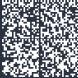
Single-sticker example:

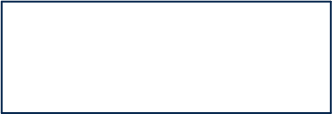
Product order code
Product identification syywwxxxxx
MBxxxx-Variant-yzz
Dual-sticker example:
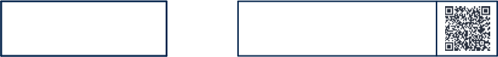
Product order code
Product identification
MBxxxx-Variant-yzz syywwxxxxx
and
• Other boards if any: board reference with revision and serial number. Examples:
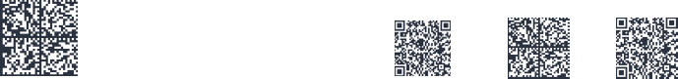
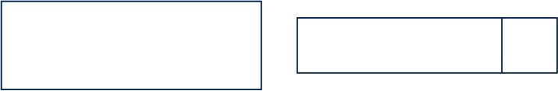
MBxxxx-Variant-yzz syywwxxxxx
syywwxxxxx
MBxxxx-Variant-yzz
or
or
or
On the main board sticker, the first line provides the product order code, and the second line the product identification.
On all board stickers, the line formatted as “MBxxxx-Variant-yzz” shows the board reference “MBxxxx”, the mounting variant “Variant” when several exist (optional), the PCB revision “y”, and the assembly revision “zz”, for example B01. The other line shows the board serial
number used for traceability.
Products and parts labeled as “ES” or “E” are not yet qualified or feature devices that are not yet qualified. STMicroelectronics disclaims any responsibility for consequences arising from their use. Under no circumstances will STMicroelectronics be liable for the customer's use of these engineering samples. Before deciding to use these engineering samples for
qualification activities, contact STMicroelectronics' quality department.
“ES” or “E” marking examples of location:
• On the targeted STM32 that is soldered on the board (for an illustration of STM32 marking, refer to the STM32 datasheet Package information paragraph at the
www.st.com website).
• Next to the evaluation tool ordering part number that is stuck or silk-screen printed on the board.
Some boards feature a specific STM32 device version, which allows the operation of any bundled commercial stack/library available. This STM32 device shows a “U” marking option at the end of the standard part number and is not available for sales.
To use the same commercial stack in their applications, the developers might need to purchase a part number specific to this stack/library. The price of those part numbers includes the stack/library royalties.

64/91 UM1724 Rev 17

UM1724 Nucleo.64 boards information

8.2 Product history

Table 34. Product history

Order  code | Product  identification | Product details | Product change description | Product limitations
NUCLEO-F030R8 | NUCLEOF030R8/ | MCU:  – STM32F030R8T6  silicon revision ‘B’ or ‘2’ or ‘1’ | Initial revision | No limitation
NUCLEO-F030R8 | NUCLEOF030R8/ | MCU errata sheet:  – STM32F030x4/x6/x8/xC device errata (ES0219) | Initial revision | No limitation
NUCLEO-F030R8 | NUCLEOF030R8/ | Boards:  – MB1136-F030R8-C01  – MB1136-F030R8-C03  – MB1136-F030R8-C04 (main board) | Initial revision | No limitation
NUCLEO-F030R8 | NUF030R8$AU1 | MCU:  – STM32F030R8T6  silicon revision ‘B’ or ‘2’ or ‘1’ | Packaging: plastic blister replaced by a carton box | No limitation
NUCLEO-F030R8 | NUF030R8$AU1 | MCU errata sheet:  – STM32F030x4/x6/x8/xC device errata (ES0219) | Packaging: plastic blister replaced by a carton box | No limitation
NUCLEO-F030R8 | NUF030R8$AU1 | Boards:  – MB1136-F030R8-C04 (main board) | Packaging: plastic blister replaced by a carton box | No limitation
NUCLEO-F030R8 | NUF030R8$KU1 | MCU:  – STM32F030R8T6  silicon revision ‘B’ or ‘2’ or ‘1’ | – Board stickers format changed | No limitation
NUCLEO-F030R8 | NUF030R8$KU1 | MCU errata sheet:  – STM32F030x4/x6/x8/xC device errata (ES0219) | – Board stickers format changed | No limitation
NUCLEO-F030R8 | NUF030R8$KU1 | Boards:  – MB1136-F030R8-C04 (main board) | – Board stickers format changed | No limitation

UM1724 Rev 17 65/91

Table 34. Product history (continued)

Order  code | Product  identification | Product details | Product change description | Product limitations
NUCLEO-F072RB | NUCLEOF072RB/ | MCU:  – STM32F072RBT6  silicon revision ‘Y’ or ‘1’ | Initial revision | No limitation
NUCLEO-F072RB | NUCLEOF072RB/ | MCU errata sheet:  – STM32F072x8/xB  device errata (ES0223) | Initial revision | No limitation
NUCLEO-F072RB | NUCLEOF072RB/ | Boards:  – MB1136-F072RB-C01  – MB1136-F072RB-C03  – MB1136-F072RB-C04 (main board) | Initial revision | No limitation
NUCLEO-F072RB | NUF072RB$AU1 | MCU:  – STM32F072RBT6  silicon revision ‘Y’ or ‘1’ | – Main board revision changed  – Packaging: plastic blister replaced by a carton box | No limitation
NUCLEO-F072RB | NUF072RB$AU1 | MCU errata sheet:  – STM32F072x8/xB  device errata (ES0223) |  | No limitation
NUCLEO-F072RB | NUF072RB$AU1 | Boards:  – MB1136-F072RB-C05 (main board) |  | No limitation
NUCLEO-F072RB | NUF072RB$KU1 | MCU:  – STM32F072RBT6 silicon revision ‘2’ | – MCU silicon revision changed  – Board sticker format changed | No limitation
NUCLEO-F072RB | NUF072RB$KU1 | MCU errata sheet:  STM32F072x8/xB device errata (ES0223) |  | No limitation
NUCLEO-F072RB | NUF072RB$KU1 | Boards:  MB1136-F072RB-C05 (main board) |  | No limitation

66/91 UM1724 Rev 17

Table 34. Product history (continued)

Order  code | Product  identification | Product details | Product change description | Product limitations
NUCLEO-F103RB | NUCLEOF103RB/ | MCU:  – STM32F103RBT6  silicon revision ‘X’ or ‘2’ | Initial revision | No limitation
NUCLEO-F103RB | NUCLEOF103RB/ | MCU errata sheet:  – STM32F101x8/B,  STM32F102x8/B and  STM32F103x8/B  medium-density device limitations (ES096) | Initial revision | No limitation
NUCLEO-F103RB | NUCLEOF103RB/ | Boards:  – MB1136-F103RB-C01  – MB1136-F103RB-C02  – MB1136-F103RB-C03  – MB1136-F103RB-C04 (main board) | Initial revision | No limitation
NUCLEO-F103RB | NUF103RB$AU1 | MCU:  – STM32F103RBT6  silicon revision ‘X’ or ‘2’ | – Main board revision changed  – Packaging: plastic blister replaced by a carton box | No limitation
NUCLEO-F103RB | NUF103RB$AU1 | MCU errata sheet:  – STM32F101x8/B,  STM32F102x8/B and  STM32F103x8/B  medium-density device limitations (ES096) |  | No limitation
NUCLEO-F103RB | NUF103RB$AU1 | Boards:  – MB1136-F103RB-C05 (main board) |  | No limitation
NUCLEO-F103RB | NUF103RB$KU1 | MCU:  – STM32F103RBT6  silicon revision ‘X’ or ‘2’ | Board stickers format changed | No limitation
NUCLEO-F103RB | NUF103RB$KU1 | MCU errata sheet:  – STM32F101x8/B,  STM32F102x8/B and  STM32F103x8/B  medium-density device limitations (ES096) | Board stickers format changed | No limitation
NUCLEO-F103RB | NUF103RB$KU1 | Boards:  – MB1136-F103RB-C05 (main board) | Board stickers format changed | No limitation

UM1724 Rev 17 67/91

Table 34. Product history (continued)

Order  code | Product  identification | Product details | Product change description | Product limitations
NUCLEO-F302R8 | NUCLEOF302R8/ | MCU:  – STM32F302R8T6 silicon revision ‘Z’ | Initial revision | No limitation
NUCLEO-F302R8 | NUCLEOF302R8/ | MCU errata sheet:  – STM32F302x6/x8 device errata (ES0247) | Initial revision | No limitation
NUCLEO-F302R8 | NUCLEOF302R8/ | Boards:  – MB1136-F302R8-C01  – MB1136-F302R8-C02  – MB1136-F302R8-C03  – MB1136-F302R8-C04 (main board) | Initial revision | No limitation
NUCLEO-F302R8 | NUF302R8$AU1 | MCU:  – STM32F302R8T6 silicon revision ‘Z’ | Packaging: plastic blister replaced by a carton box | No limitation
NUCLEO-F302R8 | NUF302R8$AU1 | MCU errata sheet:  – STM32F302x6/x8 device errata (ES0247) | Packaging: plastic blister replaced by a carton box | No limitation
NUCLEO-F302R8 | NUF302R8$AU1 | Boards:  – MB1136-F302R8-C04 (main board) | Packaging: plastic blister replaced by a carton box | No limitation

68/91 UM1724 Rev 17

Table 34. Product history (continued)

Order  code | Product  identification | Product details | Product change description | Product limitations
NUCLEO-F401RE | NUCLEOF401RE/ | MCU:  – STM32F401RET6  silicon revision ‘Z’ or ‘1’ | Initial revision | No limitation
NUCLEO-F401RE | NUCLEOF401RE/ | MCU errata sheet:  – STM32F401xD and STM32F401xE device errata (ES0299) | Initial revision | No limitation
NUCLEO-F401RE | NUCLEOF401RE/ | Boards:  – MB1136-F401RE-C01  – MB1136-F401RE-C02  – MB1136-F401RE-C03  – MB1136-F401RE-C04 (main board) | Initial revision | No limitation
NUCLEO-F401RE | NUF401RE$AU1 | MCU:  – STM32F401RET6  silicon revision ‘Z’ or ‘1’ | Packaging: plastic blister replaced by a carton box | No limitation
NUCLEO-F401RE | NUF401RE$AU1 | MCU errata sheet:  – STM32F401xD and STM32F401xE device errata (ES0299) | Packaging: plastic blister replaced by a carton box | No limitation
NUCLEO-F401RE | NUF401RE$AU1 | Boards:  – MB1136-F401RE-C04 (main board) | Packaging: plastic blister replaced by a carton box | No limitation
NUCLEO-F401RE | NUF401RE$KU1 | MCU:  – STM32F401RET6  silicon revision ‘Z’ or ‘1’ | Board stickers format changed | No limitation
NUCLEO-F401RE | NUF401RE$KU1 | MCU errata sheet:  – STM32F401xD and STM32F401xE device errata (ES0299) | Board stickers format changed | No limitation
NUCLEO-F401RE | NUF401RE$KU1 | Boards:  – MB1136-F401RE-C04 (main board) | Board stickers format changed | No limitation

UM1724 Rev 17 69/91

Table 34. Product history (continued)

Order  code | Product  identification | Product details | Product change description | Product limitations
NUCLEO-L053R8 | NUCLEOL053R8/ | MCU:  – STM32L053R8T6 silicon revision ‘X’ | Initial revision | No limitation
NUCLEO-L053R8 | NUCLEOL053R8/ | MCU errata sheet:  – STM32L05xxx/L06xxx device errata (ES0251) | Initial revision | No limitation
NUCLEO-L053R8 | NUCLEOL053R8/ | Boards:  – MB1136-L053R8-C01  – MB1136-L053R8-C02  – MB1136-L053R8-C03  – MB1136-L053R8-C04 (main board) | Initial revision | No limitation
NUCLEO-L053R8 | NUL053R8$AU1 | MCU:  – STM32L053R8T6 silicon revision ‘X’ | – Main board revision changed  – Packaging: plastic blister replaced by a carton box | No limitation
NUCLEO-L053R8 | NUL053R8$AU1 | MCU errata sheet:  – STM32L05xxx/L06xxx device errata (ES0251) |  | No limitation
NUCLEO-L053R8 | NUL053R8$AU1 | Boards:  – MB1136-L053R8-C05 (main board) |  | No limitation
NUCLEO-L053R8 | NUL053R8$KU1 | MCU:  – STM32L053R8T6  silicon revision ‘X’ or ‘P’ | Board stickers format changed | No limitation
NUCLEO-L053R8 | NUL053R8$KU1 | MCU errata sheet:  – STM32L05xxx/L06xxx device errata (ES0251) | Board stickers format changed | No limitation
NUCLEO-L053R8 | NUL053R8$KU1 | Boards:  – MB1136-L053R8-C05 (main board) | Board stickers format changed | No limitation

70/91 UM1724 Rev 17

Table 34. Product history (continued)

Order  code | Product  identification | Product details | Product change description | Product limitations
NUCLEO-L152RE | NUCLEOL152RE/ | MCU:  – STM32L152RET6 silicon revision ‘Z’ | Initial revision | No limitation
NUCLEO-L152RE | NUCLEOL152RE/ | MCU errata sheet:  – STM32L15xxE  STM32L15xVD-X  STM32L162xE  STM32L162xVD-X  device errata (ES0242) | Initial revision | No limitation
NUCLEO-L152RE | NUCLEOL152RE/ | Boards:  – MB1136-L152RE-C01  – MB1136-L152RE-C02  – MB1136-L152RE-C03  – MB1136-L152RE-C04 (main board) | Initial revision | No limitation
NUCLEO-L152RE | NUL152RE$AU1 | MCU:  – STM32L152RET6 silicon revision ‘Z’ | – Main board revision changed  – Packaging: plastic blister replaced by a carton box | No limitation
NUCLEO-L152RE | NUL152RE$AU1 | MCU errata sheet:  – STM32L15xxE  STM32L15xVD-X  STM32L162xE  STM32L162xVD-X  device errata (ES0242) |  | No limitation
NUCLEO-L152RE | NUL152RE$AU1 | Boards:  – MB1136-L152RE-C05 (main board) |  | No limitation
NUCLEO-L152RE | NUL152RE$KU1 | MCU:  – STM32L152RET6 silicon revision ‘Z’ | Board sticker format changed | No limitation
NUCLEO-L152RE | NUL152RE$KU1 | MCU errata sheet:  STM32L15xxE  STM32L15xVD-X  STM32L162xE  STM32L162xVD-X device errata (ES0242) | Board sticker format changed | No limitation
NUCLEO-L152RE | NUL152RE$KU1 | Boards:  MB1136-L152RE-C05 (main board) | Board sticker format changed | No limitation

UM1724 Rev 17 71/91

Table 34. Product history (continued)

Order  code | Product  identification | Product details | Product change description | Product limitations
NUCLEO-F091RC | NUCLEOF091RC/ | MCU:  – STM32F091RCT6 silicon revision ‘A’ | Initial revision | No limitation
NUCLEO-F091RC | NUCLEOF091RC/ | MCU errata sheet:  – STM32F091xB/xC  device errata (ES0282) | Initial revision | No limitation
NUCLEO-F091RC | NUCLEOF091RC/ | Boards:  – MB1136-F091RC-C02  – MB1136-F091RC-C03  – MB1136-F091RC-C04 (main board) | Initial revision | No limitation
NUCLEO-F091RC | NUF091RC$AU1 | MCU:  – STM32F091RCT6 silicon revision ‘A’ | – Main board revision changed  – Packaging: plastic blister replaced by a carton box | No limitation
NUCLEO-F091RC | NUF091RC$AU1 | MCU errata sheet:  – STM32F091xB/xC  device errata (ES0282) |  | No limitation
NUCLEO-F091RC | NUF091RC$AU1 | Boards:  – MB1136-F091RC-C05 (main board) |  | No limitation

72/91 UM1724 Rev 17

Table 34. Product history (continued)

Order  code | Product  identification | Product details | Product change description | Product limitations
NUCLEO-F303RE | NUCLEOF303RE/ | MCU:  – STM32F303RET6 silicon revision ‘Y’ | Initial revision | No limitation
NUCLEO-F303RE | NUCLEOF303RE/ | MCU errata sheet:  – STM32F303xD  STM32F303xE Rev Y device limitations  (ES0261) | Initial revision | No limitation
NUCLEO-F303RE | NUCLEOF303RE/ | Boards:  – MB1136-F303RE-C02  – MB1136-F303RE-C03  – MB1136-F303RE-C04 (main board) | Initial revision | No limitation
NUCLEO-F303RE | NUF303RE$AU1 | MCU:  – STM32F303RET6 silicon revision ‘Y’ | – Main board revision changed  – Packaging: plastic blister replaced by a carton box | No limitation
NUCLEO-F303RE | NUF303RE$AU1 | MCU errata sheet:  – STM32F303xD  STM32F303xE Rev Y device limitations  (ES0261) |  | No limitation
NUCLEO-F303RE | NUF303RE$AU1 | Boards:  – MB1136-F303RE-C05 (main board) |  | No limitation

UM1724 Rev 17 73/91

Table 34. Product history (continued)

Order  code | Product  identification | Product details | Product change description | Product limitations
NUCLEO-F334R8 | NUCLEOF334R8/ | MCU:  – STM32F334R8T6 silicon revision ‘Z’ | Initial revision | No limitation
NUCLEO-F334R8 | NUCLEOF334R8/ | MCU errata sheet:  – STM32F334x4/x6/x8  Rev Z device limitations (ES0258) | Initial revision | No limitation
NUCLEO-F334R8 | NUCLEOF334R8/ | Boards:  – MB1136-F334R8-C02  – MB1136-F334R8-C03  – MB1136-F334R8-C04 (main board) | Initial revision | No limitation
NUCLEO-F334R8 | NUF334R8$AU1 | MCU:  – STM32F334R8T6 silicon revision ‘Z’ | – Main board revision changed  – Packaging: plastic blister replaced by a carton box | No limitation
NUCLEO-F334R8 | NUF334R8$AU1 | MCU errata sheet:  – STM32F334x4/x6/x8  Rev Z device limitations (ES0258) |  | No limitation
NUCLEO-F334R8 | NUF334R8$AU1 | Boards:  – MB1136-F334R8-C05 (main board) |  | No limitation
NUCLEO-F334R8 | NUF334R8$KU1 | MCU:  – STM32F334R8T6  silicon revision ‘Z’ or ‘1’ | Board stickers format changed | No limitation
NUCLEO-F334R8 | NUF334R8$KU1 | MCU errata sheet:  – STM32F334x4/x6/x8  Rev Z device limitations (ES0258) | Board stickers format changed | No limitation
NUCLEO-F334R8 | NUF334R8$KU1 | Boards:  – MB1136-F334R8-C05 (main board) | Board stickers format changed | No limitation

74/91 UM1724 Rev 17

Table 34. Product history (continued)

Order  code | Product  identification | Product details | Product change description | Product limitations
NUCLEO-F411RE | NUCLEOF411RE/ | MCU:  – STM32F411RET6 silicon revision ‘A’ | Initial revision | No limitation
NUCLEO-F411RE | NUCLEOF411RE/ | MCU errata sheet:  – STM32F411xC/xE  device errata (ES0287) | Initial revision | No limitation
NUCLEO-F411RE | NUCLEOF411RE/ | Boards:  – MB1136-F411RE-C02  – MB1136-F411RE-C03  – MB1136-F411RE-C04 (main board) | Initial revision | No limitation
NUCLEO-F411RE | NUF411RE$AU1 | MCU:  – STM32F411RET6 silicon revision ‘A’ | Packaging: plastic blister replaced by a carton box | No limitation
NUCLEO-F411RE | NUF411RE$AU1 | MCU errata sheet:  – STM32F411xC/xE  device errata (ES0287) | Packaging: plastic blister replaced by a carton box | No limitation
NUCLEO-F411RE | NUF411RE$AU1 | Boards:  – MB1136-F411RE-C04 (main board) | Packaging: plastic blister replaced by a carton box | No limitation
NUCLEO-F411RE | NUF411RE$KU1 | MCU:  – STM32F411RET6  silicon revision ‘A’ or ‘1’ | Board stickers format changed | No limitation
NUCLEO-F411RE | NUF411RE$KU1 | MCU errata sheet:  – STM32F411xC/xE  device errata (ES0287) | Board stickers format changed | No limitation
NUCLEO-F411RE | NUF411RE$KU1 | Boards:  – MB1136-F411RE-C04 (main board) | Board stickers format changed | No limitation

UM1724 Rev 17 75/91

Table 34. Product history (continued)

Order  code | Product  identification | Product details | Product change description | Product limitations
NUCLEO-F410RB | NUCLEOF410RB/ | MCU:  – STM32F410RBT6 silicon revision ‘A’ | Initial revision | No limitation
NUCLEO-F410RB | NUCLEOF410RB/ | MCU errata sheet:  – STM32F410x8  STM32F410xB device errata (ES0325) | Initial revision | No limitation
NUCLEO-F410RB | NUCLEOF410RB/ | Boards:  – MB1136-F410RB-C03  – MB1136-F410RB-C04 (main board) | Initial revision | No limitation
NUCLEO-F410RB | NUF410RB$AU1 | MCU:  – STM32F410RBT6 silicon revision ‘A’ | Packaging: plastic blister replaced by a carton box | No limitation
NUCLEO-F410RB | NUF410RB$AU1 | MCU errata sheet:  – STM32F410x8  STM32F410xB device errata (ES0325) | Packaging: plastic blister replaced by a carton box | No limitation
NUCLEO-F410RB | NUF410RB$AU1 | Boards:  – MB1136-F410RB-C04 (main board) | Packaging: plastic blister replaced by a carton box | No limitation

76/91 UM1724 Rev 17

Table 34. Product history (continued)

Order  code | Product  identification | Product details | Product change description | Product limitations
NUCLEO-F446RE | NUCLEOF446RE/ | MCU:  – STM32F446RET6 silicon revision ‘A’ | Initial revision | No limitation
NUCLEO-F446RE | NUCLEOF446RE/ | MCU errata sheet:  – STM32F446xC/xE  device errata (ES0298) | Initial revision | No limitation
NUCLEO-F446RE | NUCLEOF446RE/ | Boards:  – MB1136-F446RE-C03  – MB1136-F446RE-C04 (main board) | Initial revision | No limitation
NUCLEO-F446RE | NUF446RE$AU1 | MCU:  – STM32F446RET6 silicon revision ‘A’ | Packaging: plastic blister replaced by a carton box | No limitation
NUCLEO-F446RE | NUF446RE$AU1 | MCU errata sheet:  – STM32F446xC/xE  device errata (ES0298) | Packaging: plastic blister replaced by a carton box | No limitation
NUCLEO-F446RE | NUF446RE$AU1 | Boards:  – MB1136-F446RE-C04 (main board) | Packaging: plastic blister replaced by a carton box | No limitation
NUCLEO-F446RE | NUF446RE$KU1 | MCU:  – STM32F446RET6  silicon revision ‘A’ or ‘1’ | Board stickers format changed | No limitation
NUCLEO-F446RE | NUF446RE$KU1 | MCU errata sheet:  – STM32F446xC/xE  device errata (ES0298) | Board stickers format changed | No limitation
NUCLEO-F446RE | NUF446RE$KU1 | Boards:  – MB1136-F446RE-C04 (main board) | Board stickers format changed | No limitation

UM1724 Rev 17 77/91

Table 34. Product history (continued)

Order  code | Product  identification | Product details | Product change description | Product limitations
NUCLEO-F070RB | NUCLEOF070RB/ | MCU:  – STM32F070RBT6 silicon revision ‘1’ | Initial revision | No limitation
NUCLEO-F070RB | NUCLEOF070RB/ | MCU errata sheet:  – STM32F070x6/xB  device errata (ES0291) | Initial revision | No limitation
NUCLEO-F070RB | NUCLEOF070RB/ | Boards:  – MB1136-F070RB-C03  – MB1136-F070RB-C04 (main board) | Initial revision | No limitation
NUCLEO-F070RB | NUF070RB$AU1 | MCU:  – STM32F070RBT6 silicon revision ‘1’ | – Main board revision changed  – Packaging: plastic blister replaced by a carton box | No limitation
NUCLEO-F070RB | NUF070RB$AU1 | MCU errata sheet:  – STM32F070x6/xB  device errata (ES0291) |  | No limitation
NUCLEO-F070RB | NUF070RB$AU1 | Boards:  – MB1136-F070RB-C05 (main board) |  | No limitation
NUCLEO-F070RB | NUF070RB$KU1 | MCU:  – STM32F070RBT6 silicon revision ‘2’ | – Board stickers format changed  – MCU silicon revison changed | No limitation
NUCLEO-F070RB | NUF070RB$KU1 | MCU errata sheet:  – STM32F070x6/xB  device errata (ES0291) |  | No limitation
NUCLEO-F070RB | NUF070RB$KU1 | Boards:  – MB1136-F070RB-C05 (main board) |  | No limitation

78/91 UM1724 Rev 17

Table 34. Product history (continued)

Order  code | Product  identification | Product details | Product change description | Product limitations
NUCLEO-L073RZ | NUCLEOL073RZ/ | MCU:  – STM32L073RZT6 silicon revision ‘Z’ | Initial revision | No limitation
NUCLEO-L073RZ | NUCLEOL073RZ/ | MCU errata sheet:  – STM32L07xxx/L08xxx device errata (ES0292) | Initial revision | No limitation
NUCLEO-L073RZ | NUCLEOL073RZ/ | Boards:  – MB1136-L073RZ-C03  – MB1136-L073RZ-C04 (main board) | Initial revision | No limitation
NUCLEO-L073RZ | NUL073RZ$AU1 | MCU:  – STM32L073RZT6 silicon revision ‘Z’ | – Main board revision changed  – Packaging: plastic blister replaced by a carton box | No limitation
NUCLEO-L073RZ | NUL073RZ$AU1 | MCU errata sheet:  – STM32L07xxx/L08xxx device errata (ES0292) |  | No limitation
NUCLEO-L073RZ | NUL073RZ$AU1 | Boards:  – MB1136-L073RZ-C05 (main board) |  | No limitation
NUCLEO-L073RZ | NUL073RZ$KU1 | MCU:  – STM32L073RZT6  silicon revision ‘Z’ or ‘P’ | Board stickers format changed | No limitation
NUCLEO-L073RZ | NUL073RZ$KU1 | MCU errata sheet:  – STM32L07xxx/L08xxx device errata (ES0292) | Board stickers format changed | No limitation
NUCLEO-L073RZ | NUL073RZ$KU1 | Boards:  – MB1136-L073RZ-C05 (main board) | Board stickers format changed | No limitation

UM1724 Rev 17 79/91

Table 34. Product history (continued)

Order  code | Product  identification | Product details | Product change description | Product limitations
NUCLEO-L452RE | NUCLEOL452RE/ | MCU:  – STM32L452RET6 silicon revision ‘Y’ | Initial revision | No limitation
NUCLEO-L452RE | NUCLEOL452RE/ | MCU errata sheet:  – STM32L452xx device errata (ES0388) | Initial revision | No limitation
NUCLEO-L452RE | NUCLEOL452RE/ | Boards:  – MB1136-L452RE-C03  – MB1136-L452RE-C04 (main board) | Initial revision | No limitation
NUCLEO-L452RE | NUL452RE$AU1 | MCU:  – STM32L452RET6 silicon revision ‘Y’ | Packaging: plastic blister replaced by a carton box | No limitation
NUCLEO-L452RE | NUL452RE$AU1 | MCU errata sheet:  – STM32L452xx device errata (ES0388) | Packaging: plastic blister replaced by a carton box | No limitation
NUCLEO-L452RE | NUL452RE$AU1 | Boards:  – MB1136-L452RE-C05 (main board) | Packaging: plastic blister replaced by a carton box | No limitation
NUCLEO-L452RE | NUL452RE$KU1 | MCU:  – STM32L452RET6 silicon revision ‘Y’ | Board sticker format changed | No limitation
NUCLEO-L452RE | NUL452RE$KU1 | MCU errata sheet:  – STM32L452xx device errata (ES0388) | Board sticker format changed | No limitation
NUCLEO-L452RE | NUL452RE$KU1 | Boards:  – MB1136-L452RE-C05 (main board) | Board sticker format changed | No limitation

80/91 UM1724 Rev 17

Table 34. Product history (continued)

Order  code | Product  identification | Product details | Product change description | Product limitations
NUCLEO-L476RG | NUCLEOL476RG/ | MCU:  – STM32L476RGT6 silicon revision ‘4’ | Initial revision | No limitation
NUCLEO-L476RG | NUCLEOL476RG/ | MCU errata sheet:  – STM32L476xx/STM32L4 86xx device errata  (ES0250) | Initial revision | No limitation
NUCLEO-L476RG | NUCLEOL476RG/ | Boards:  – MB1136-L476RG-C03  – MB1136-L476RG-C04 (main board) | Initial revision | No limitation
NUCLEO-L476RG | NUL476RG$AU1 | MCU:  – STM32L476RGT6 silicon revision ‘4’ | – Main board revision changed  – Packaging: plastic blister replaced by a carton box | No limitation
NUCLEO-L476RG | NUL476RG$AU1 | MCU errata sheet:  – STM32L476xx/STM32L4 86xx device errata  (ES0250) |  | No limitation
NUCLEO-L476RG | NUL476RG$AU1 | Boards:  – MB1136-L476RG-C05 (main board) |  | No limitation
NUCLEO-L476RG | NUL476RG$KU1 | MCU:  – STM32L476RGT6 silicon revision ‘4’ | Board stickers format changed | No limitation
NUCLEO-L476RG | NUL476RG$KU1 | MCU errata sheet:  – STM32L476xx/STM32L4 86xx device errata  (ES0250) | Board stickers format changed | No limitation
NUCLEO-L476RG | NUL476RG$KU1 | Boards:  – MB1136-L476RG-C05 (main board) | Board stickers format changed | No limitation

UM1724 Rev 17 81/91

Table 34. Product history (continued)

Order  code | Product  identification | Product details | Product change description | Product limitations
NUCLEO-L010RB | NUCLEOL010RB/ | MCU:  – STM32L010RBT6 silicon revision ‘Z’ | Initial revision | No limitation
NUCLEO-L010RB | NUCLEOL010RB/ | MCU errata sheet:  – STM32L010xx device errata (ES0483) | Initial revision | No limitation
NUCLEO-L010RB | NUCLEOL010RB/ | Boards:  – MB1136-L010RB-C03  – MB1136-L010RB-C04 (main board) | Initial revision | No limitation
NUCLEO-L010RB | NUL010RB$AU1 | MCU:  – STM32L010RBT6 silicon revision ‘Z’ | Packaging: plastic blister replaced by a carton box | No limitation
NUCLEO-L010RB | NUL010RB$AU1 | MCU errata sheet:  – STM32L010xx device errata (ES0483) | Packaging: plastic blister replaced by a carton box | No limitation
NUCLEO-L010RB | NUL010RB$AU1 | Boards:  – MB1136-L010RB-C05 (main board) | Packaging: plastic blister replaced by a carton box | No limitation

82/91 UM1724 Rev 17

8.3 Board revision history

Table 35. Board revision history

Board  reference | Board variant and revision | Board change description | Board  limitations
MB1136 (main board) | F030R8-C01  F072RB-C01  F103RB-C01  F302R8-C01  F401RE-C01  L053R8-C01  L152RE-C01 | Initial revision | No limitation
MB1136 (main board) | F072RB-C02  F091RC-C02  F103RB-C02  F302R8-C02  F303RE-C02  F334R8-C02  F401RE-C02  F411RE-C02  L053R8-C02  L152RE-C02 | Add LSE:  – X2(32 KHz)  – R34 and R36 changed from OFF to 0 Ω  – C31 and C32 changed from OFF to 10 pF  – SB48 and SB49 changed from ON to OFF Remove HSE:  – SB16 and SB50 changed from OFF to ON  – SB55 changed from ON to OFF | No limitation
MB1136 (main board) | F030R8-C03  F070RB-C03  F072RB-C03  F091RC-C03  F103RB-C03  F302R8-C03  F303RE-C03  F334R8-C03  F401RE-C03  F410RB-C03  F411RE-C03  F446RE-C03  L010RB-C04  L053R8-C03  L073RZ-C03  L152RE-C03  L452RE-C03  L476RG-C03 | – X2 changed to ABS25-32.768KHZ-6-TB  – C31 and C32 changed from 10 to 4.3 pF  – C26 changed from 2.2 to 4.7 µF | No limitation

UM1724 Rev 17 83/91

Table 35. Board revision history (continued)

Board  reference | Board variant and revision | Board change description | Board  limitations
MB1136 (main board) | F030R8-C04  F070RB-C04  F072RB-C04  F091RC-C04  F103RB-C04  F302R8-C04  F303RE-C04  F334R8-C04  F401RE-C04  F410RB-C04  F411RE-C04  F446RE-C04  L010RB-C04  L053R8-C04  L073RZ-C04  L152RE-C04  L452RE-C04  L476RG-C04 | Reference for transistor (T2) changed from STMICROELECTRONICS STS7PF30L to STMICROELECTRONICS STS9P3LLH6 | No limitation
MB1136 (main board) | F070RB-C05  F072RB-C05  F091RC-C05  F103RB-C05  F303RE-C05  F334R8-C05  L010RB-C05  L053R8-C05  L073RZ-C05  L152RE-C05  L452RE-C05  L476RG-C05 | – USB connector (CN1) changed  – Buttons (B1 and B2) changed  – Minor changes in serigraphy | No limitation

84/91 UM1724 Rev 17

9 Federal Communications Commission (FCC) and ISED Canada

Compliance Statements

9.1 FCC Compliance Statement
Part 15.19
This device complies with Part 15 of the FCC Rules. Operation is subject to the following two conditions: (1) this device may not cause harmful interference, and (2) this device must accept any interference received, including interference that may cause undesired
operation.
Part 15.21
Any changes or modifications to this equipment not expressly approved by
STMicroelectronics may cause harmful interference and void the user's authority to operate this equipment.
Part 15.105
This equipment has been tested and found to comply with the limits for a Class B digital
device, pursuant to part 15 of the FCC Rules. These limits are designed to provide
reasonable protection against harmful interference in a residential installation. This
equipment generates uses and can radiate radio frequency energy and, if not installed and used in accordance with the instructions, may cause harmful interference to radio
communications. However, there is no guarantee that interference will not occur in a
particular installation. If this equipment does cause harmful interference to radio or
television reception which can be determined by turning the equipment off and on, the user is encouraged to try to correct interference by one or more of the following measures:
• Reorient or relocate the receiving antenna.
• Increase the separation between the equipment and receiver.
• Connect the equipment into an outlet on a circuit different from that to which the receiver is connected.
• Consult the dealer or an experienced radio/TV technician for help.
Note: Use a shielded USB cable with a length of less than 0.5 m and ferrite on the computer side, like WURTH ELEKTRONIK 742 711 12.
Responsible party (in the USA)
Francesco Doddo
STMicroelectronics, Inc.
200 Summit Drive | Suite 405 | Burlington, MA 01803
USA
Telephone: +1 781-472-9634

UM1724 Rev 17 85/91

9.2 ISED Compliance Statement
ISED Canada ICES-003 Compliance Label: CAN ICES-3 (B) / NMB-3 (B).
Étiquette de conformité à la NMB-003 d'ISDE Canada : CAN ICES-3 (B) / NMB-3 (B).
Note: Use a shielded USB cable with a length of less than 0.5 m and ferrite on the computer side,
like WURTH ELEKTRONIK 742 711 12.

86/91 UM1724 Rev 17

10 Product disposal

Disposal of this product: WEEE (Waste Electrical and Electronic Equipment)
(Applicable in Europe)

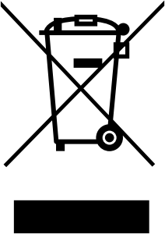
This symbol on the product, accessories, or accompanying documents indicates that the product and its electronic accessories must not be disposed of with household waste at the end of their working life.
To prevent possible harm to the environment and human health from uncontrolled waste disposal, separate these items from other types of waste and recycle them responsibly at a designated collection point to promote the sustainable reuse of material resources.
Household users:
Contact the retailer that you purchased the product from or your local authority for details of your nearest designated collection point.
Business users:
Contact your dealer or supplier for further information.

UM1724 Rev 17 87/91

Revision history

Table 36. Document revision history

Date | Revision | Changes
10-Feb-2014 | 1 | Initial release.
13-Feb-2014 | 2 | Updated Figure 1, Chapter 5.5 and Table 10.
11-Apr-2014 | 3 | Extended the applicability to NUCLEO-F302R8. Updated Table 1: Ordering information, Section 6. 11: Arduino connectors and  Section 6. 12: ST morpho connector.  Updated Figure 1
10-June-2014 | 4 | Updated the board figure: Figure 1.  Updated HSE and LSE configuration description: Section 6.7.1, Section 5.5, and Section 6.7.2. Extended the applicability to  NUCLEO-F334R8, NUCLEO-F411RE, and NUCLEO-L053R8.
20-June-2014 | 5 | Updated the electrical schematics figures: Figure 27, Figure 28, Figure 29, and Figure 30.  Refer to the AN2867 for the oscillator design guide for STM32 microcontrollers in Section 6.7. 1: OSC clock supply and  Section 6.7.2: OSC 32 KHz clock supply.
30-Sept-2014 | 6 | Extended the applicability to NUCLEO-F091RC and NUCLEO- F303RE;  Updated Table 1: Ordering information;  Updated Table 11: Arduino connectors on NUCLEO-F030R8,  NUCLEO-F070RB, NUCLEO-F072RB, NUCLEO-F091RC;  Updated Table 26: ST morpho connector on NUCLEO-F072RB, NUCLEO-F091RC, NUCLEO-F303RE, NUCLEO-F334R8;  Updated Figure 6: Typical configuration;  Added Figure 13: NUCLEO-F091RC;  Added Figure 16: NUCLEO-F303RE;  Updated Section 6.7.2: OSC 32 KHz clock supply;  Updated Figure 27: Top and Power(1/4) ,Figure 28: STM32 MCU;

88/91 UM1724 Rev 17

Table 36. Document revision history (continued)

Date | Revision | Changes
19-Jan-2015 | 7 | Extended the applicability to NUCLEO-F070RB, NUCLEO- L073RZ, and NUCLEO-L476RG;  Updated Table 1: Ordering information;  Updated Section 6.2: Embedded ST-LINK/V2-1;  Updated Section 6. 7. 1: OSC clock supply;  Added Figure 11: NUCLEO-F070RB;  Added Figure 21: NUCLEO-L073RZ;  Added Figure 24: NUCLEO-L476RG  Updated Table 11: Arduino connectors on NUCLEO-F030R8, NUCLEO-F070RB, NUCLEO-F072RB, NUCLEO-F091RC  Added Table 18: Arduino connectors on NUCLEO-L073RZ  Added Table 23: Arduino connectors on NUCLEO-L476RG  Added Table 25: ST morpho connector on NUCLEO-F070RB Updated Table 30: ST morpho connector on NUCLEO-L053R8, NUCLEO-L073RZ, NUCLEO-L152RE  Added Table 32: ST morpho connector on NUCLEO-L476RG Updated schematics from Figure 27: Top and Power(1/4) to Figure 30: Extension connectors
08-Jul-2015 | 8 | Extended the applicability to Updated Table 1: Ordering information;  Added Figure 25: NUCLEO-F446RE and Figure 26: NUCLEO- F410RB  Updated Section 6. 11: Arduino connectors on page 37 and  Section 6. 12: ST morpho connector on page 53
04-Aug-2015 | 9 | Added Section 5.4: NUCLEO-L476RG bootloader limitations.
17-Nov-2015 | 10 | Updated Section 6.9: Solder bridges and Section 6.7. 1: OSC clock supply.
29-Nov-2015 | 11 | Updated Introduction, Section 3: Ordering information,  Section 6. 10: Extension connectors, Section 6. 11: Arduino  connectors, Section 6. 12: ST morpho connector to add NUCLEO- L452RE.
15-Dec-2017 | 12 | Updated document title and cover page.  Updated Chapter 2: Product marking and Section 5.3:  Development toolchains.  Expanded document scope to NUCLEO-L010RB:  – Updated Table 1: Ordering information  – Updated Table 18: Arduino connectors on NUCLEO-L010RB and NUCLEO-L073RZ  – Updated Table 21: NUCLEO-L073RZ and NUCLEO-L010RB  – Updated Table 30: ST morpho connector on NUCLEO-L010RB, NUCLEO-L053R8, NUCLEO-L073RZ, NUCLEO-L152RE
3-Apr-2019 | 13 | Updated document title, Introduction, Chapter 2: Ordering information, Section 2. 1: Product marking, Section 2.2:  Codification, and Section 5. 1: Getting started.  Added Chapter 3: Development environment and Section 3.3: Demonstration software.
UM1724 Rev 17 89/91

Table 36. Document revision history (continued)

Date | Revision | Changes
19-Aug-2020 | 14 | Updated the connector reference in the description of SB54 and SB55 in Table 10: Solder bridges.  Removed pin 10 duplicated rows in Table 11: ARDUINO®  connectors on NUCLEO-F030R8, NUCLEO-F070RB, NUCLEO- F072RB, NUCLEO-F091RC, Table 12: ARDUINO® connectors on NUCLEO-F103RB, Table 16: ARDUINO® connectors on  NUCLEO-F401RE and NUCLEO-F411RE, and Table 19:  ARDUINO® connectors on NUCLEO-F446RE. Removed electrical schematics.  Added Section 7 including Product marking, Board revision history, and Board known limitations.
14-Apr-2025 | 15 | Added Section 3.4: EDA resources, Section 5: Safety recommendations, Table 34: Product history and Table 35: Board revision history, and Section 9: Federal Communications Commission (FCC) and ISED Canada Compliance Statements.  Updated Section 3.1: System requirements, Figure 2: Hardware  block diagram, Section 7.4: Embedded ST-LINK/V2-1, Section 7.4.1: Driver, and Section 8.1: Product marking.  ® ™  Removed the references to Arm Mbed .
19-May-2025 | 16 | Updated Table 34: Product history.
30-Sep-2025 | 17 | Updated Table 34: Product history.

90/91 UM1724 Rev 17

IMPORTANT NOTICE – READ CAREFULLY

STMicroelectronics NV and its subsidiaries (“ST”) reserve the right to make changes, corrections, enhancements, modifications, and improvements to ST products and/or to this document at an<y time without notice.

In the event of any conflict between the provisions of this document and the provisions of any contractual arrangement in force between the purchasers and ST, the provisions of such contractual arrangement shall prevail.

The purchasers should obtain the latest relevant information on ST products before placing orders. ST products are sold pursuant to ST’s terms and conditions of sale in place at the time of order acknowledgment.

The purchasers are solely responsible for the choice, selection, and use of ST products and ST assumes no liability for application assistance or the design of the purchasers’ products.

No license, express or implied, to any intellectual property right is granted by ST herein.

Resale of ST products with provisions different from the information set forth herein shall void any warranty granted by ST for such product.

If the purchasers identify an ST product that meets their functional and performance requirements but that is not designated for the purchasers' market segment, the purchasers shall contact ST for more information.

ST and the ST logo are trademarks of ST. For additional information about ST trademarks, refer to www.st.com/trademarks. All other product or service names are the property of their respective owners.

Information in this document supersedes and replaces information previously supplied in any prior versions of this document.

© 2025 STMicroelectronics – All rights reserved

UM1724 Rev 17 91/91

